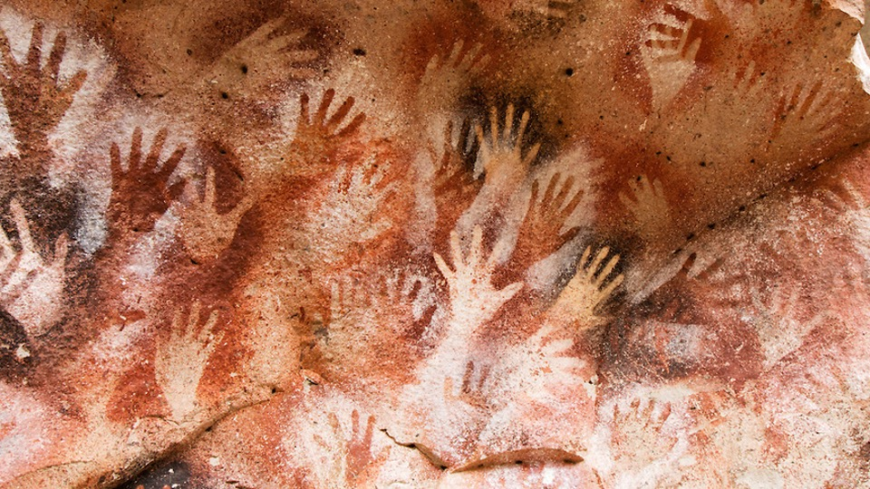

Syllabus for MEJO 588: Emerging Technologies

UNC Hussman School of Journalism and Media
Professor: William Ammerman, Adjunct Instructor
wamm@unc.edu
Mobile: 919-614-1275

Classroom: Curtis Media Center Room 201/202
Class Time: Mondays from 2:00 - 4:45 pm
Office Hours: By Appointment

Course Website: Canvas
Format: Classes will be taught in person and simultaneously via Zoom ID: 98220293124

Course Description
This course will introduce students to storytelling with emerging technologies such as CGI, Virtual Reality, Augmented Reality, 360 Video, and Artificial Intelligence. Students will learn:
  - Media production design concepts (Human Centered Design)
  - How Virtual Reality works with the brain
  - What makes a good VR and AR experience
  - Storytelling in both 360 video, AR, and VR.
  - Technical skills to produce storytelling including drones and robots

Course Materials and Costs
Students should immediately purchase and begin to read:
The Invisible Brand: Marketing in the Age of Automation, Big Data, and Machine Learning
By William Ammerman, McGraw-Hill, 2019

The book is available through UNC’s bookstore in hardcover, or through Amazon in hardcover, Kindle, and audiobook. All formats are acceptable.

Finish reading Chapter 1 before the second day of class on August 22nd.

Other course materials will include access to online video assignments which may have a rental cost, plus costs associated with attending the optional Immersive Van Gogh exhibit, and the optional cost of VR gear. Total costs for the course including the textbook should be less than $200.

We have a limited number of VR headsets, so do not run out and buy your own until we’ve discussed it in class.

Calendar
Classes are currently scheduled to meet on Mondays from 2:00 – 4:45pm in Carroll Hall, Room 268. Students will be notified by email if there are any changes to the class schedule, meeting room, or calendar. The current course calendar follows:

Date | Class | Topic
15-Aug | 1 | Introduction
22-Aug | 2 | Algorithms
29-Aug | 3 | 3D CGI
4-Sep | Labor Day (Off)
12-Sep | 4 | MMORPGs as Stories
19-Sep | 5 | Virtual Reality
26-Sep | Well Being (Off)
3-Oct | 6 | Augmented Reality
10-Oct | 7 | Metaverse
17-Oct | 8 | 360 Video
24-Oct | 9 | Drones
31-Oct | 10 | Blockchain
7-Nov | 11 | Robots
14-Nov | 12 | Artificial Intelligence
21-Nov | 13 | Natural Language Processing
28-Nov | 14 | The Future of Storytelling
5-Dec | 15 | Exam

Field Trips
There are currently 3 field trips away from the classroom scheduled for this course.
1] An extra-credit assignment is available for all students who attend the Immersive Van Gogh exhibit in Raleigh any day before the exhibit ends on September 30th. Ticket prices vary, and you are responsible for your own transportation. The assignment is posted in Canvas and due by October 7th to receive credit. https://vangoghexpo.com/raleigh/
2] Class will meet at the NC Botanical Gardens on Monday, October 17th at 2pm in the main building. The facility is closed on Mondays, and we have received permission to create a 360 Video walkthrough of the gardens to be used on their official website. Students will receive additional credit for public service hours for the time they spend on this project.
3] On Monday, October 24th, at 2pm we will be working with the UNC athletic department’s drone operator to learn about drone operation and photography. The location will be announced in class and via email.

Attendance and Assignments
Please communicate with me early about potential absences. Please be aware that you are bound by the Honor Code when making a request for a University approved absence.

University Policy:
No right or privilege exists that permits a student to be absent from any class meetings, except for these University Approved Absences:
- Authorized University activities
- Disability/religious observance/pregnancy, as required by law and approved by Accessibility Resources and Service and/or the Equal Opportunity and Compliance Office (EOC)
- Significant health condition and/or personal/family emergency as approved by the Office of the Dean of Students, Gender Violence Service Coordinators, and/or the Equal Opportunity and Compliance Office (EOC).

Grading Policy and Scale
Quizzes and Tests must be taken when they are given in class and no excuses will be accepted other than those outlined above under the official University Policy for approved absences.
All projects are assigned a due date. If you are unable to complete the project by the due date, you will receive an automatic extension of 1 week if you notify me BEFORE the due date. Students who fail to turn in a project and fail to request an extension prior to the due date will not receive credit for the assignment.

Honor Code and Plagiarism
I expect that each student will conduct himself or herself within the guidelines of the University honor system (http://honor.unc.edu). All academic work should be done with the high levels of honesty and integrity that this University demands. You are expected to produce your own work in this class. If you have any questions about your responsibility or your instructor’s responsibility as a faculty member under the Honor Code, please see the course instructor or Senior Associate Dean C. A. Tuggle, or you may speak with a representative of the Student Attorney Office or the Office of the Dean of Students.

It is acceptable to use coding resources such as tutorials, libraries, and some source code on sites like GitHub but the software license must allow for the usage and the code should be credited, linked, and commented in your source code and credited visibly on the site either in the footer or a credits page.

Grading
Assignments | Points
Attendance (1 point per class up to a maximum of 10 points) | 10 Points
Projects (5 projects worth 10 points each) | 50 Points
Quizzes | 20 Points
Final Exam | 20 Points
Total | 100 Points

Undergraduate Grading Scale | Grade
A | >=94%
A- | 90-93%
B + | 87-89%
B | 85-86%
B- | 80-83%
C+ | 77-79%
C | 74-76%
C- | 70-73%
D+ | 67-69%
D | 64-66%
D- | 60-63%
F | <=59%

Graduate Grading Scale | Grade
H | High Pass - Clear Excellence
P | Pass - Entirely Satisfactory Graduate Work
L | Low Pass - Inadequate Graduate Work
F | Fail

Accreditation
The UNC Hussman School of Journalism and Media’s accrediting body outlines several values you should be aware of and competencies you should be able to demonstrate by the time you graduate from our program. Learn more about them here:
http://www2.ku.edu/~acejmc/PROGRAM/PRINCIPLES.SHTML#vals&comps
Policy on Non-Discrimination
The University is committed to providing an inclusive and welcoming environment for all members of our community and to ensuring that educational and employment decisions are based on individuals’ abilities and qualifications. Consistent with this principle and applicable laws, the University’s Policy Statement on Non-Discrimination offers access to its educational programs and activities as well as employment terms and conditions without respect to race, color, gender, national origin, age, religion, creed, genetic information, disability, veteran’s status, sexual orientation, gender identity or gender expression. Such a policy ensures that only relevant factors are considered, and that equitable and consistent standards of conduct and performance are applied.
If you are experiencing harassment or discrimination, you can seek assistance and file a report through the Report and Response Coordinators (see contact info at safe.unc.edu) or the Equal Opportunity and Compliance Office, or online to the EOC at https://eoc.unc.edu/report-an-incident/.
Diversity
I strive to make this classroom an inclusive space for all students. Please let me know if there is anything I can do to improve; I appreciate any suggestions. More broadly, our school has adopted diversity and inclusion mission and vision statements with accompanying goals. These complement the University policy on prohibiting harassment and discrimination. In summary, UNC is committed to providing an inclusive and welcoming environment for all members of our community and does not discriminate in offering access to its educational programs and activities on the basis of age, gender, race, color, national origin, religion, creed, disability, veteran’s status, sexual orientation, gender identity, or gender expression. The Dean of Students (Suite 1106, Student Academic Services Building, CB# 5100, 450 Ridge Road, Chapel Hill, NC 27599-5100 or [919] 966-4042) has been designated to handle inquiries regarding the University’s nondiscrimination policies.
Seeking Help
If you need individual assistance, it’s your responsibility to contact me. If you are serious about wanting to improve your performance in the course, the time to seek help is as soon as you are aware of the problem – whether the problem is difficulty with course material, a disability, or an illness.

Special Accommodations
The University of North Carolina at Chapel Hill facilitates the implementation of reasonable accommodations, including resources and services, for students with disabilities, chronic medical conditions, a temporary disability, or pregnancy complications resulting in barriers to fully accessing University courses, programs, and activities.

Accommodations are determined through the Office of Accessibility Resources and Service (ARS) for individuals with documented qualifying disabilities in accordance with applicable state and federal laws. See the ARS Website for contact information: https://ars.unc.edu or email ars@unc.edu. If you need information about disabilities visit the Accessibility Services website at https://accessibility.unc.edu/

Counseling and Psychological Services
CAPS is strongly committed to addressing the mental health needs of a diverse student body through timely access to consultation and connection to clinically appropriate services, whether for short or long-term needs. Go to their website: https://caps.unc.edu/ or visit their facilities on the third floor of the Campus Health Services building for a walk-in evaluation to learn more.

Bio for William Ammerman
William Ammerman is an award-winning author and retired media executive with over 30 years of industry experience. He is currently a board advisor and angel investor focused on early-stage digital media ventures. Recently, he accepted an appointment as Adjunct at the UNC Hussman School of Journalism and Media where he teaches a course on emerging technologies. His book, “The Invisible Brand: Marketing in the Age of Automation, Big Data, and Machine Learning” (McGraw-Hill) won the 2019 Marketing & Sales Book of the Year and was recognized with a Gold Medal by the Nonfiction Authors Association. He is a popular keynote speaker and guest lecturer at major industry groups and universities worldwide.

Formerly, Mr. Ammerman owned DVD Marketing Inc. where he produced and distributed commemorative DVDs for ABC Sports and ESPN, and he also served in senior executive roles at Engaged Media, Tribune Media, Capitol Broadcasting, and Hearst Television. He earned his Bachelor’s from the University of Michigan, his Master’s from the University of North Carolina, and an executive certificate in Artificial Intelligence from MIT.

