INTRODUCTION TO

DIGITAL STORYTELLING

UNC-Chapel Hill | Hussman School of Journalism and Media | MEJO 121 | Syllabus link: bit.ly/SP22_MEJO121_Syllabus Course materials: bit.ly/SP22_MEJO121_CouseMaterials

Welcome to this introductory media technology skills class at the UNC Hussman School of Journalism and Media. Our simple goals are to introduce you to some of the tools and skills needed to engage in multimedia storytelling in online environments. We aim to demystify the technical aspects of audiovisual information packaging by engaging in basic hands-on video and web exercises.
However, what distinguishes this class from a skills-only course is its focus on storytelling. We ultimately intend to provide familiarity with the tools and an understanding of how to develop a narrative story with all these tools. These are the skill sets needed for various professions in media and journalism.

For this semester, let’s look at these next 16 weeks as a time to create a video you are proud of, a design element that enhances a solid story, and a basic website that will impress a potential employer. It is a lot to cover, but if we take it step-by-step, we can do this!

Classroom and meeting time
Time: 5:00-6:15pm
Days: Tuesday and Thursday (January 11- May 3)
Final: May 3 @ 7:00pm
Our class will meet on Zoom January 11- January 24
Carroll Hall Room 268
Sakai site: https://sakai.unc.edu/portal/site/sp22_mejo121

Online class meetings
At this point in the semester, you should plan on attending all class meetings via zoom from January 11- January 24th. We hope to be meeting in person January 24th through May 3. There may be occasions, however, where pre-recorded content is available in lieu of attending class or we will hold class on Zoom. You will be informed about these days in advance and links to pre-recorded content will be provided.
If online, meet at this URL: https://unc.zoom.us/j/99137818650

Instructor
Adjunct Professor: Alex M. Sanchez
asanchez@unc.edu | alexmousan02@gmail.com
Office Hours: Tuesdays and Thursdays 2:00pm- 4:00pm (Email me for an appointment within those hours)
Zoom office: https://unc.zoom.us/j/95000934687

Required Supplies

There are no textbooks for this class, but there are required purchases. Be aware that financial aid funds can be used for these items. If you believe you will have a challenge with these purchases, please contact Stephanie Willen Brown parkadmin@listserv.unc.edu or text (919) 442-8077, the director of the Hussman School's Park Library.

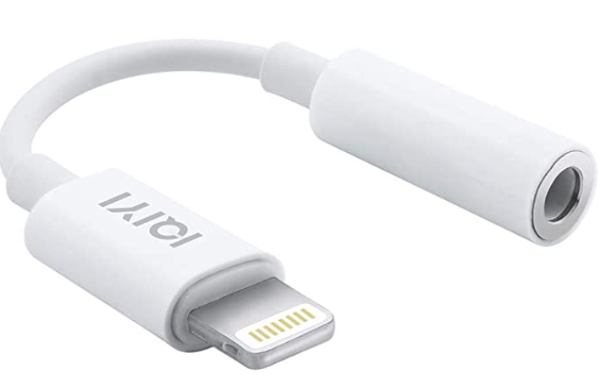
Smartphone
For your video assignments, you will record with your smartphone. Please let the instructor know if you do not own a smartphone. NOTE: If you will be using an iPhone 7 or higher, you also need a 3.5 mm headphone jack adapter (usually included with your iPhone purchase and pictured at left) to be able to use the lavalier microphone.

Headphones
Must have a standard mini jack (⅛’’). Any wired (non-Bluetooth / not wireless) headphones you might use with your phone will work. Here is a recommended option, although standard earbuds with a mini-jack also will work.

Wired lavalier microphone with headphone monitoring
A lavalier will be needed for the best audio quality. You will need to purchase a lavalier microphone with headphone monitoring (pictured below). Here is the link to an option on Amazon: Lavalier microphone. The cost for this one is approximately $25. Additional microphone option here.

Tripod with a smartphone mount
You will need to purchase a tripod and mount for your phone. Cost: About $20. You may find an example here (pictured below).
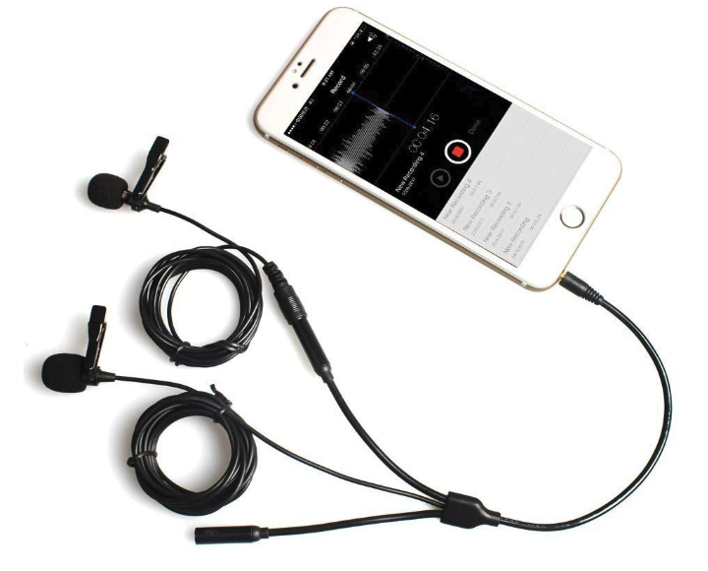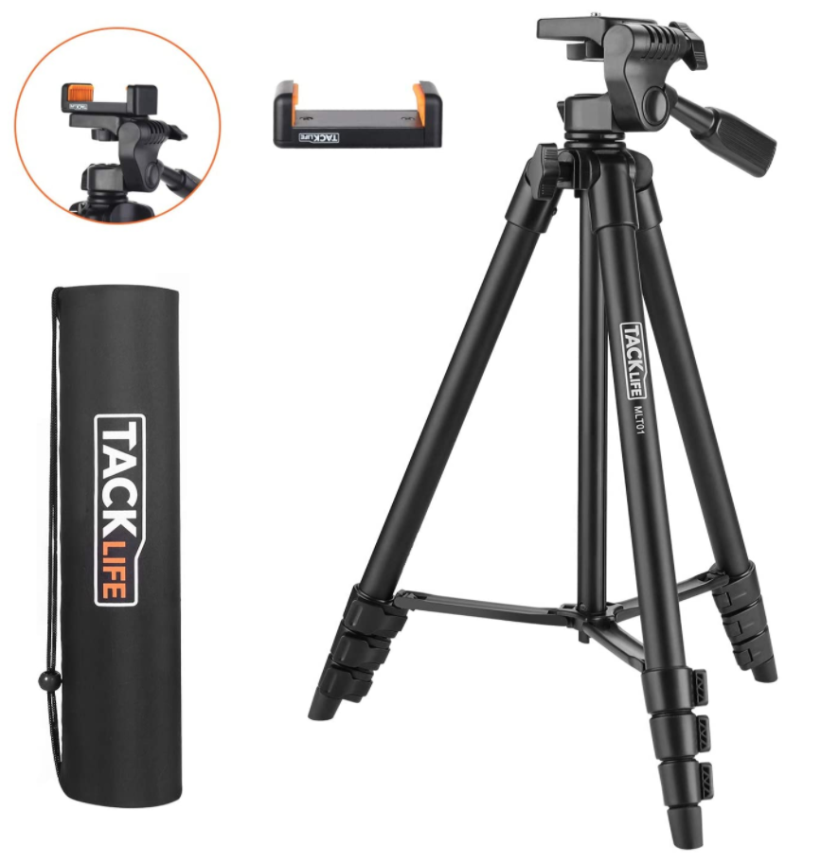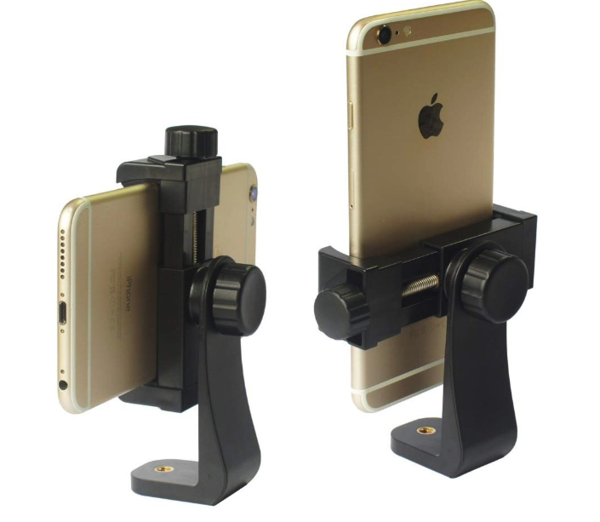

Domain name & hosting space.
You will need to purchase these products for the Web portion of this class for approximately $20-$30 for your first year. Please note that it is your responsibility to cancel this service once the course is complete. More details about this process will be provided in class. If you already have these products, you may reuse them for this class. Please inform your instructor if this is the case.

Equipment guides
For more information and tutorials related to the 121 class equipment, please see these tutorials on the Park Library website: https://guides.lib.unc.edu/equipment-room/instruction-manuals or contact Stephanie Willen Brown (swbrown@unc.edu), the director of the Hussman School's Park Library.
Recommended Supplies
USB external hard drive/flash drive
Specs: Minimum 64GB flash drive, must be USB 3.0 for fastest file transfer speeds. Recommended investing in a larger external hard drive to backup all files for this course and others.
Click here for a link to a recommended flash drive (64GB).
Click here for a link to a recommended flash drive (128GB).
Click here for a link to a recommended external hard drive (2TB).
Required Digital Access

LinkedIn Learning
Follow the instructions here to access LinkedIn Learning with your onyen. https://software.sites.unc.edu/linkedin/

Adobe Premiere
Follow the instructions here to create an Adobe ID and install the required software for free: http://software.sites.unc.edu/software/adobe-creative-cloud/

YouTube or Vimeo account
You must use or create an account to publish your videos for this course. A YouTube account is included with any Gmail account, and there is no storage limit on YouTube accounts. A Vimeo account is free to create, but free accounts have restrictions on the total GB you can upload each week. Publishing your work on YouTube is easy and free, but Vimeo can have a more professional reputation.

Course Goals and Accreditation

The Hussman School of Journalism and Media accrediting body outlines a number of values you should be aware of and competencies you should be able to demonstrate by the time you graduate from our program.
Learn more about them here: http://www2.ku.edu/~acejmc/PROGRAM/PRINCIPLES.SHTML#vals&comps

No single course could possibly give you all of these values and competencies; but collectively, our classes are designed to build your abilities in each of these areas. In this class, we will address a number of the values and competencies, with special emphasis on the "Professional values and competencies" listed below.

- Understand concepts and apply theories in the use and presentation of images and information.
- Demonstrate an understanding of professional ethical principles and work ethically in pursuit of truth, accuracy, fairness, and diversity.
- Think critically, creatively, and independently.
- Apply tools and technologies appropriate for the communications professions in which they work.

Late Assignments
Accepting late assignments is unfair to the students who have sacrificed to turn their work in on time. An automatic 10 percent deduction will be applied to each assignment turned in after the time it is due, provided the assignment is turned in on the same day it is due. An additional 10% deduction will be applied for each subsequent 24 hours that pass after the due date/time (i.e., 10 percent is taken off for each day).
Independent Online Research
To teach you the necessary software tools to create your stories, this course will combine in-class demonstrations with online tutorials and videos. As beginners, it is inevitable that questions and technical problems will arise as you work with these tools. It is also not possible to cover every detail of a tool through in-class demos or assigned videos. The assignments will require you to learn how to learn new things independently, outside of direct instruction. While your instructor is always available to answer your questions and clarify any topic, this course will challenge you to troubleshoot your technical problems and figure out answers to your questions through independent online research. Before asking your question a technical or software-related question like “how do I…” or “ … isn’t working”, it is expected that you will research your question online. Invest some time looking at manuals, forums and documentation sites to see if someone else has addressed your question or problem before. If you have conducted independent research online and still can’t find your answer, reach out to your instructor through email, in class, or during office hours. In addition to asking your question, share what you learned during your research, a description of your problem, and any relevant screenshots.
Grading
Work is graded according to the highest professional standards. Grades in percentages are:

- A = 93-100%,
- A- = 90-92%,
- B+ = 87-89%,
- B = 83-86%,
- B- = 80-82%,
- C+ = 77-79%,
- C = 73-76%,
- C- = 70-72%,
- D+ = 67-69%,
- D = 60-66%
- F = 59% or below
Below is a guideline for how grades are described within this course:
- A: nearly perfect in execution, quality of work is exceptional
- A-: work is impressive in quality, very few problems in any area
- B+: very good performance, did more than required, might struggle in one area only
- B: solid effort, met all requirements, solid application of skill
- B-: needs a bit more polish, a good handle on overall concepts
- C+: good in one area of work, but consistent problems with another area
- C: followed instructions, seems to understand basics but did the minimum to pass
- C-: has glimpses of potential in a limited range
- D: did not demonstrate an understanding of the basics but tried
- F: did not demonstrate effort or understanding of basics, incomplete

Grading Criteria

In-class participation (see description below) | 5%
Video course work (includes exercises, quizzes, and a video project) | 50%
Web/Design course work (includes exercises, quizzes, and a portfolio project) | 25%
Final project (includes final web page design and story/package integration) | 20%
In-class participation is your contribution within the scope of each class period, including arriving to live or online class meetings on time, asking questions, offering insights during class discussions, sharing feedback with peers, and general engagement with the material. The quality of your participation will be assigned a letter grade based on the guidelines above at the end of the course. You may check-in with your instructor at any time during the course for individual feedback about the quality of your participation.
Exercises are assigned to familiarize you with the skills needed to complete the projects and are graded on completion and execution quality. Engagement with the exercises and quizzes will prepare you to achieve better work on your projects.
The video & web projects are assigned for you to demonstrate a mastery of the skills and storytelling techniques learned in class and with the exercises.
The final project is an integrated package delivered via text, design, and video and housed on your portfolio website. The package must contain integrated elements (story text, video, and any additional elements you may choose).
Syllabus Changes
The professor reserves the right to make changes to the syllabus, including project due dates and test dates. These changes will be announced as early as possible.
Attendance
Class Policy:
You are allotted two unexcused absences this semester however you must complete work on time and catch up with class materials. Please communicate with me early about potential absences.
(source: http://catalog.unc.edu/policies-procedures/attendance-grading-examination/)

ZOOM Policy:
You must participate in class whether in person or on zoom. I expect your video to be on, Zoom etiquette will be established at the beginning of the class. After the first 3 week period (January 11-January 24th) you will be expected to be in class in person. If you have extenuating circumstances you must reach out to me individually and let me know why you must be on zoom whether for one class or regularly. If you are on Zoom, Zoom etiquette must be followed (this includes your camera must be on and you must participate.)
From January 11- January 24th classes will be recorded and posted to the Sakai site so you can look back on these recordings. I cannot ensure that this will be the case for every class moving forward but I will do my best to ensure there is access to any in-class presentations.
Honor Code
I expect that each student will conduct himself or herself within the guidelines of the University honor system (http://honor.unc.edu). All academic work should be done with the high levels of honesty and integrity that this University demands. You are expected to produce your own work in this class. If you have any questions about your responsibility or your instructor’s responsibility as a faculty member under the Honor Code, please see the course instructor or Senior Associate Dean C. A. Tuggle, or you may speak with a representative of the Student Attorney Office or the Office of the Dean of Students.
ARS
The University of North Carolina at Chapel Hill facilitates the implementation of reasonable accommodations, including resources and services, for students with disabilities, chronic medical conditions, a temporary disability, or pregnancy complications resulting in barriers to fully accessing University courses, programs, and activities.
Accommodations are determined through the Office of Accessibility Resources and Service (ARS) for individuals with documented qualifying disabilities in accordance with applicable state and federal laws. See the ARS Website for contact information: https://ars.unc.edu or email ars@unc.edu.
(source: https://ars.unc.edu/faculty-staff/syllabus-statement)

Counseling and Psychological Services
CAPS is strongly committed to addressing the mental health needs of a diverse student body through timely access to consultation and connection to clinically appropriate services, whether for short or long-term needs. Go to their website: https://caps.unc.edu/ or visit their facilities on the third floor of the Campus Health Services building for a walk-in evaluation to learn more.
TITLE IX
Any student who is impacted by discrimination, harassment, interpersonal (relationship) violence, sexual violence, sexual exploitation, or stalking is encouraged to seek resources on campus or in the community. Reports can be made online to the EOC at https://eoc.unc.edu/report-an-incident/. Please contact the University’s Title IX Coordinator (Elizabeth Hall, interim – titleixcoordinator@unc.edu), Report and Response Coordinators in the Equal Opportunity and Compliance Office (reportandresponse@unc.edu), Counseling and Psychological Services (confidential), or the Gender Violence Services Coordinators (gvsc@unc.edu; confidential) to discuss your specific needs. Additional resources are available at safe.unc.edu.
Policy on Non-discrimination
The University is committed to providing an inclusive and welcoming environment for all members of our community and to ensuring that educational and employment decisions are based on individuals’ abilities and qualifications. Consistent with this principle and applicable laws, the University’s Policy Statement on Non-Discrimination offers access to its educational programs and activities as well as employment terms and conditions without respect to race, color, gender, national origin, age, religion, creed, genetic information, disability, veteran’s status, sexual orientation, gender identity or gender expression. Such a policy ensures that only relevant factors are considered and that equitable and consistent standards of conduct and performance are applied.
If you are experiencing harassment or discrimination, you can seek assistance and file a report through the Report and Response Coordinators (see contact info at safe.unc.edu) or the Equal Opportunity and Compliance Office, or online to the EOC at https://eoc.unc.edu/report-an-incident/.

Diversity Statement
I strive to make this classroom an inclusive space for all students. Please let me know if there is anything I can do to improve. More broadly, our school has adopted diversity and inclusion mission and vision statements with accompanying goals. These complement the University’s policy on prohibiting harassment and discrimination. In summary, UNC is committed to providing an inclusive and welcoming environment for all members of our community and does not discriminate in offering access to its educational programs and activities on the basis of age, gender, race, color, national origin, religion, creed, disability, veteran’s status, sexual orientation, gender identity, or gender expression. The Dean of Students (Suite 1106, Student Academic Services Building, CB# 5100, 450 Ridge Road, Chapel Hill, NC 27599-5100 or [919] 966-4042) has been designated to handle inquiries regarding the University’s nondiscrimination policies.

Mask Use
All enrolled students are required to wear a mask covering their mouth and nose at all times in our classroom. This requirement is to protect our educational community -- your classmates and me – as we learn together. If you choose not to wear a mask, or wear it improperly, I will ask you to leave immediately, and I will submit a report to the Office of Student Conduct. At that point, you will be disenrolled from this course for the protection of our educational community. Students who have an authorized accommodation from Accessibility Resources and Service have an exception. For additional information, see https://carolinatogether.unc.edu/university-guidelines-for-facemasks/.

