Syllabus for MEJO 801
Pro Seminar in Doctoral Studies
Fall 2020 1:15-4 p.m. Tuesdays
Room 340A and through Zoom
INSTRUCTOR INFORMATION

Rhonda Gibson, Ph.D. (Please call me Rhonda.)
Room 376 Carroll Hall
gibsonr@email.unc.edu (best way to reach me)
(919) 843-8296 (office)
(919) 699-6567 (cell)

Office Hours: Tuesdays 10 a.m. – noon & by appointment

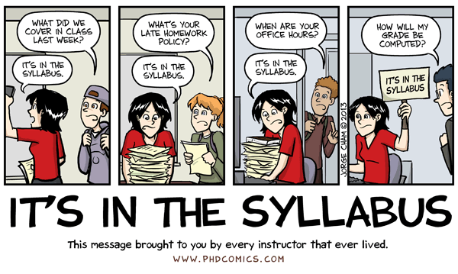

COURSE DESCRIPTION AND OBJECTIVES

This is a seminar course specifically for first-semester doctoral students in the School of Media and Journalism. It is a portal to doctoral education in which you learn about the role of doctoral studies in the academy; the expectations of someone studying for a Ph.D.; and the research, teaching, and service responsibilities of a university professor. This course will serve as an introduction to the practice of scholarship, and you will be expected to immerse yourself into the scholarly culture of the academy through attendance at research colloquia and interaction with visiting scholars.

Another significant portion of the course will be devoted to the science and art of teaching, and you’ll have the opportunity to hear from and observe award-winning teachers at UNC. You’ll learn best practices for teaching residentially and online and creating a welcoming and equitable environment for students. You’ll create a syllabus and assignments for a course that you are likely to teach during in the future and do a practice teaching session.

Lastly, you’ll learn a lot about and be welcomed into the collaborative, innovative, and rigorous culture of the Hussman School.

By the end of this course, you should…

1. Understand what is expected of a doctoral student in terms of coursework, fellowship duties, scholarly engagement, teaching, comprehensive exams, and production of a dissertation.
3. Understand the importance of a research agenda and have begun developing your own.
4. Have developed skills in course planning, classroom management, and grading/assessment.
5. Understand best practices for inclusive and equitable teaching.
6. Be skilled in developing course content for both residential and online teaching.
7. Have begun to consider how you will position yourself in the academic or industry job markets.
8. Know techniques for balancing the demands of research, teaching, and service, as well as balancing all of these with family and personal life.
9. Understand the importance of well-being and self-care for doctoral students (and humans in general)
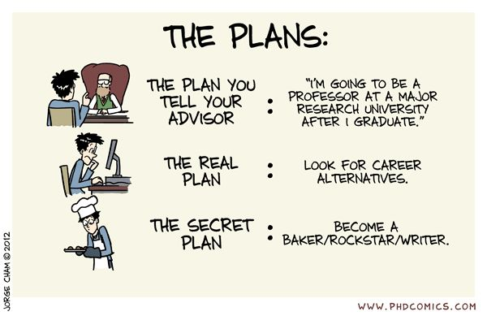

TEXTBOOKS

- Lynette Pretorius, Luke Macaulay, Basil Cahusac de Caux, (editors), Well-being in Doctoral Education: Insights and Guidance from the Student Experience (full text available at no additional charge via UNC Libraries)
- Ken Bain, What the Best College Teachers Do (full text available at no additional charge via UNC Libraries)
- Barbara Walvoord & Virginia Anderson, Effective Grading: A Tool for Learning and Assessment in College (2nd edition) (full text available at no additional charge via UNC Libraries)
- Margaret Foley-McCabe, Essentials of Online Teaching: A Standards-Based Guide (full text available at no additional charge via UNC Libraries)
- Cornell Thomas (editor), Inclusive Teaching: Presence in the Classroom (full text available at no additional charge via UNC Libraries)

ASSIGNMENTS AND GRADES

Pass (P). The level of work and performance expected of a graduate student. All assignments are complete, thoroughly researched, well written, and logically organized. In-class participation is regular and informed, demonstrating that assignments have been read and understood. Attendance is regular and punctual, except for a valid excuse, in which case the instructor is notified in advance. The student demonstrates respect for the views and comments of others.

High Pass (H). Extraordinary and clearly superior performance in all or most of the areas mentioned above. H’s are given sparingly.

Low Pass (L). Barely acceptable performance, demonstrating a weak grasp of concepts and mastery of skills, significant writing problems, or other significant deficiencies. This grade may also be assigned if a student fails to meet deadlines, fails to participate in class, misses class without an acceptable excuse and/or regularly comes late to class.

Fail (F). Unacceptable performance, consisting of, but not limited to, excessive unexcused absences, failure to turn in assignments on time, coming to class unprepared, failure to participate in class discussions, poorly written assignments, and demonstrable failure to grasp concepts and master skills.

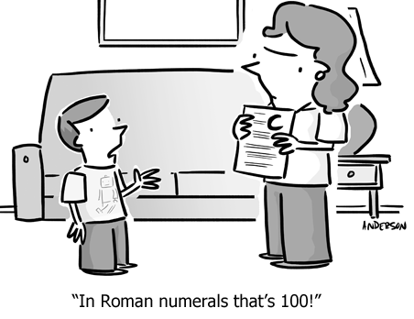
Your course grade will be based on the following items:

(Detailed instructions for each assignment will be provided under the Schedule/Syllabus/Assignments section of the course Sakai site.)

- A detailed statement of your research interests and a description of one national conference and two peer-reviewed journals that would be appropriate outlets for this research. This counts for 10% of your grade and is due by 1 p.m. on Tuesday, Sept. 22.

- A teaching presentation on a topic appropriate for a course that you will likely teach in the future. You will produce a detailed lesson plan, deliver a 50-minute class session using the lesson plan, and write a short reflection paper about the experience soon afterward. Your teaching session will be recorded. This assignment counts for 25% of your grade and must be completed by Tuesday, Nov. 10. (You are welcome to do it much earlier in the semester.)

- A reflection paper about your goals and perceived strengths and challenges as a college instructor. You will draw from class readings and discussions, your past experiences as a student and instructor, and the teaching you have observed this semester. To help you with this assignment and to expose you to various teaching styles, you will be required to attend at least two (residential or online) undergraduate class sessions this semester. Please attend courses taught by full-time or adjunct faculty, not other doctoral students. Your reflection paper should focus on your teaching goals, what you consider to be your strongest teaching-related skills, the areas you wish to improve upon, and strategies for becoming stronger in those areas. This assignment counts for 15% of the grade and is due by 1 p.m. on Tuesday, Oct. 27.

- A syllabus and series of assignments/assessments for a course you will likely teach during your doctoral program. The assignments will include a group exercise, a writing-based assessment, an examination, and a presentation-based assessment. Together these items count for 40% of your grade and are due by 1 p.m. on Tuesday, Nov. 17.

- Participation. This involves in-class participation, leading our well-being discussions, Discussion Board posts, and attendance at M-J School research colloquia (either in person or online, depending on what’s happening in the world). It is not enough to simply read the material and complete the written assignments. You are expected to be active participants in class, interacting with the instructor and your classmates, challenging ideas, and contributing new ideas based on your professional and personal experiences. Participation counts for 10% of your grade. Please understand that you have to earn your participation points; simply coming to class is not sufficient to pass this component of the course. Multiple absences will lower your class participation grade.

THE HONOR CODE

The Honor Code and the Campus Code, embodying the ideals of academic honesty, integrity and responsible citizenship, have for more than 100 years governed the performance of all academic work and student conduct at the University of North Carolina at Chapel Hill. Acceptance by a student enrolled in the University presupposes a commitment to the principles embodied in those codes and a respect for this most significant University tradition.

Your participation in this course comes with my expectation that your work will be completed in full observance of the Honor Code. Academic dishonesty in any form is unacceptable because any breach in academic integrity, however small, strikes destructively at the University’s life and work. Much learning is collaborative, and we all learn through the process of sharing. I encourage you to discuss issues and concerns about teaching and research inside and outside this class, but the work you submit is to be exclusively your own. You must be careful to give attribution wherever appropriate.
If you have any questions about your responsibility as a student or my responsibility as a faculty member under the Honor Code, please bring them to me or discuss them with someone in either the Office of the Graduate Student Attorney General or the Office of the Dean of Students.
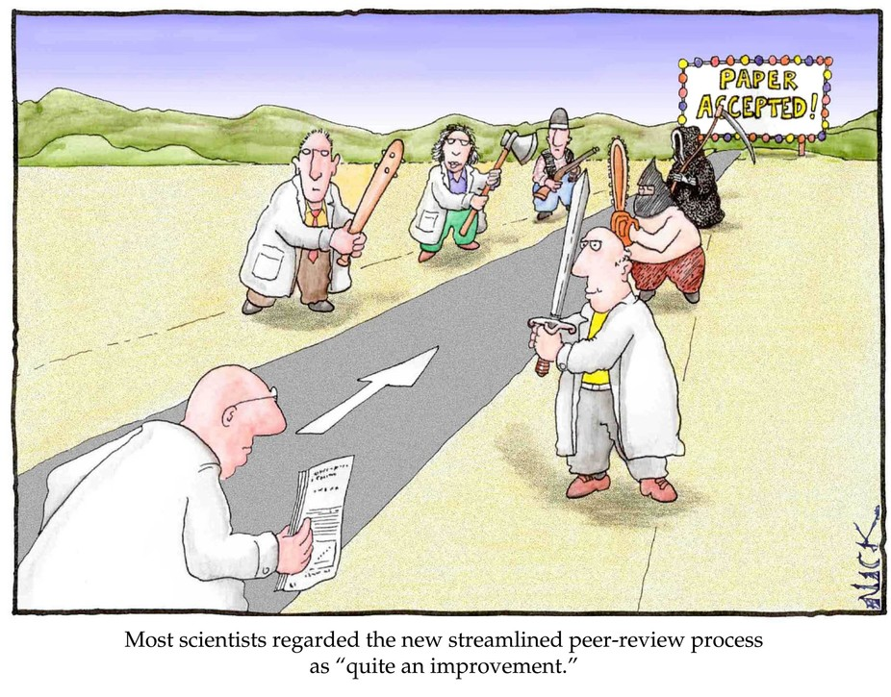
COURSE SCHEDULE
A detailed explanation of each class day’s topic, readings, and activities can be found in Weekly Lessons section of the class Sakai Site. PLEASE refer to this prior to attending class each day.
Below is a brief description of each class period’s topics and mode of instruction (in-person or through Zoom). Assigned readings, which should be done before the class period starts, are in parentheses after the day’s topics. This is all subject to change, so please refer to the Sakai site Weekly Lessons pages for the most up-to-date material.
Aug. 11: Introduction to the course and discussion of what makes a good teacher (read the course syllabus and What the Best College Teachers Do, chapters 1 & 2) (in person)
Aug. 18: The classroom environment (read What the Best College Teachers Do, chapters 4 & 6 and Inclusive Teaching, chapters 1, 2 & 5) (in person)
Aug. 25: Types of class formats; academic conferences & journals (read What the Best College Teachers Do, chapters 3 & 5 and handouts/links to conference presentation and journal information) (Zoom)
Sept. 1: Planning a course: syllabus & course objectives; program milestones (read handouts and the Ph.D. student handbook) (Zoom)
Sept. 8: Inclusive teaching goals and strategies; doctoral student well-being, part 1 (read Inclusive Teaching, chapters 3 &4 and Well-Being in Doctoral Education, chapters TBA) (in person)
Sept. 15: Assignments and assessments (read What the Best College Teachers Do, chapter 7; Effective Grading, chapters 2-5, and A Short Guide to Writing Effective Test Questions handout) (Zoom)
Sept. 22: Online teaching (read Essentials of Online Teaching, chapters 1, 3-5 & 9) (Zoom) (Research Interests Statement due by 1 p.m.)
Sept. 29: Managing class discussion and difficult topics; doctoral student well-being, part 2 (read handouts, What the Best College Teachers Do, pps. 126-134, and Well-Being in Doctoral Education, chapters TBA) (in person)
Oct. 6: Balancing teaching, research and service; vitae; time management; (read handouts, Effective Grading, chapters 6 & 7) (in person)
Oct. 13: Types of scholarship; external funding (read handouts) (Zoom)
Oct. 20: After the Ph.D.: The academic job market, alt-acs, and industry positions (read handouts) (Zoom)
Oct. 27: Teaching materials workshop (read each other’s materials) (in person) (Teaching reflection paper due by 1 p.m. today.)
Nov. 3: Motivating students; classroom assessment techniques (read handouts and Effective Grading, chapter 2) (Zoom) (ELECTION DAY!)
Nov. 10: Doctoral student well-being, part 3 (read Well-Being in Doctoral Education, chapters TBA) (in person) (Teaching session must be completed by today.)
Nov. 17: Classroom technologies workshop; teaching experience reflection (in person) (Syllabus & assignments due by 1 p.m. today.)
Final Exam Period (sometime between Nov. 17-22) (Zoom)

ATTENDANCE/FINAL EXAM PERIOD
You are expected to be in class for the entirety of each class period. If something important prevents you from attending class, please notify the instructor in advance. Our final exam period will be TBA (the university hasn’t set these yet). We will meet online during this time, and attendance is required.

