INTRODUCTION TO

DIGITAL STORYTELLING

UNC-Chapel Hill | Hussman School of Journalism and Media | MEJO 121.08 |

Welcome to this introductory media technology skills class at the UNC Hussman School of Journalism and Media. Our simple goals are to introduce you to some of the tools and skills needed to engage in multimedia storytelling in online environments. We aim to demystify the technical aspects of audiovisual information packaging by engaging in basic hands-on video and web exercises.
However, what distinguishes this class from a skills-only course is its focus on storytelling. We ultimately intend to provide familiarity with the tools and an understanding of how to develop a narrative story with all these tools. These are the skill sets needed for various professions in media and journalism.

Meeting time

Tuesday & Thursday: 1:15 p.m. – 2:30 p.m.
Online – Zoom link will be emailed and posted on Sunday before the week begins

Instructor
Prof. Lindsay King
lindsay01ki@gmail.com
Office Hours: Monday - Friday by appointment. E-mail lindsay.king@unc.edu to schedule a virtual meeting.
Required Supplies
There are no textbooks for this class, but there are required purchases. Be aware that financial aid funds can be used for these items. If you believe you will have a challenge with these purchases, please contact Stephanie Willen Brown (swbrown@unc.edu), the director of the Hussman School's Park Library.
Your required supplies include:

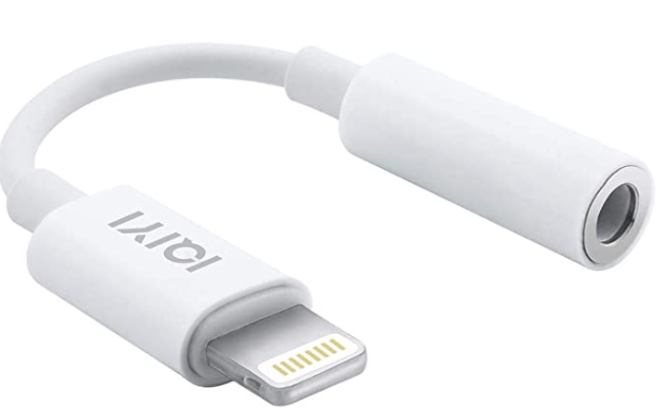
Smartphone
For your video assignments, you will record with your smartphone. Please let the instructor know if you do not own a smartphone. NOTE: If you will be using an iPhone 7 or higher, you also need a 3.5 mm headphone jack adapter (usually included with your iPhone purchase and pictured at left) to be able to use the lavalier microphone.

Headphones
Must have a standard mini jack (⅛’’). Any wired (non-Bluetooth / not wireless) headphones you might use with your phone will work. Here is a recommended option, although standar earbuds with a mini jack also will work.

Wired lavalier microphone with headphone monitoring
A lavalier will be needed for the best audio quality. You will need to purchase a lavalier microphone with headphone monitoring (pictured below). Here is the link to an option on Amazon: Lavalier microphone. The cost for this one is approximately $25. Additional microphone option here.

Tripod with smartphone mount
You will need to purchase a tripod and mount for your phone. Cost: About $20. You may find an example here (pictured below).
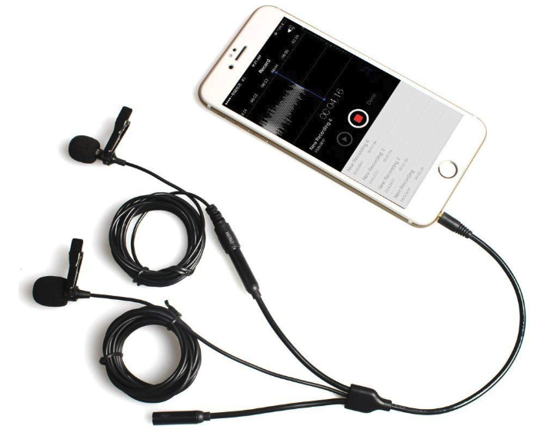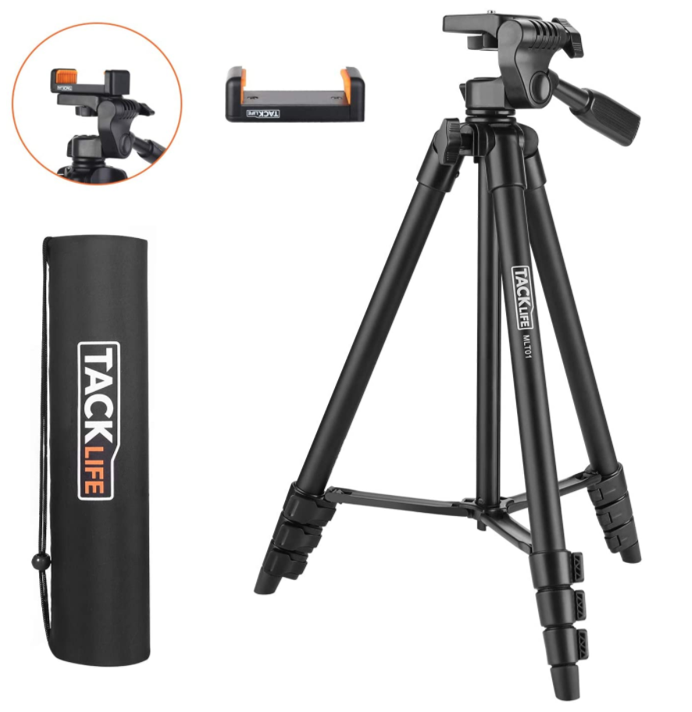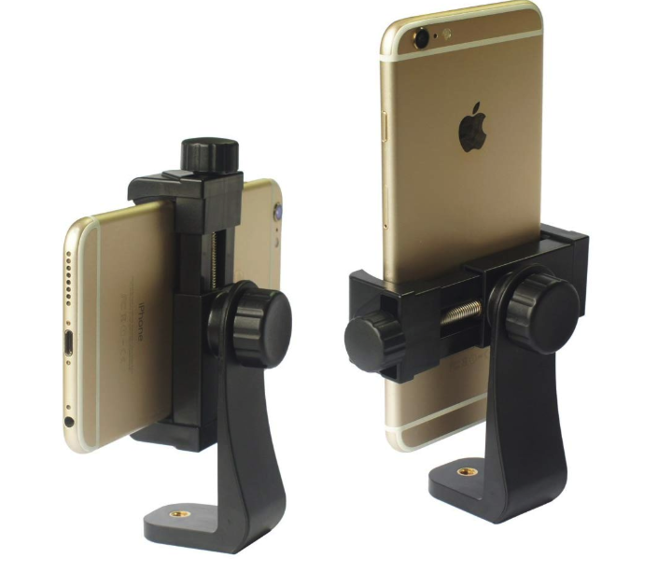

Domain name & hosting space.
You will need to purchase these products for the Web portion of this class for approximately $20-$30 for your first year. More details will be provided in class. You should not purchase these items until directed. NOTE: If you already have these products, you may reuse them for this class. Please inform the instructor if this is the case. Also note that it is your responsibility to cancel this service once the course is complete.
Equipment guides
For more information and tutorials related to the 121 class equipment, please see these tutorials on the Park Library website: https://guides.lib.unc.edu/mejo-equipment-room/videos
Recommended Supplies
USB external hard drive / flash drive
Specs: Minimum 64GB flash drive, must be USB 3.0 for fastest file transfer speeds. Recommended to invest in a larger external hard drive to backup all files for this course and others.
Click here for a link to a recommended flash drive (64GB).
Click here for a link to a recommended flash drive (128GB).
Click here for a link to a recommended external hard drive (2TB).
FiLMiCPro app: FiLMiC Pro that provides the features of professional video cameras for iPhone and Android. The cost of this app is $14.99.
More information here: https://www.filmicpro.com/
Required Digital Access

LinkedIn Learning
Follow the instructions here to access LinkedIn Learning with your onyen. https://software.sites.unc.edu/linkedin/

Adobe Premiere
Follow the instructions here to create an Adobe ID and install the required software for free: http://software.sites.unc.edu/software/adobe-creative-cloud/

YouTube or Vimeo account
You must use or create an account to publish your videos for this course. A YouTube account is included with any Gmail account, and there is no storage limit on YouTube accounts. A Vimeo account is free to create, but free accounts have restrictions on the total GB you can upload each week. Publishing your work on YouTube is easy and free, but Vimeo can have a more professional reputation.

Course Goals and Accreditation

The Hussman School of Journalism and Media accrediting body outlines a number of values you should be aware of and competencies you should be able to demonstrate by the time you graduate from our program.
Learn more about them here: http://www2.ku.edu/~acejmc/PROGRAM/PRINCIPLES.SHTML#vals&comps

No single course could possibly give you all of these values and competencies; but collectively, our classes are designed to build your abilities in each of these areas. In this class, we will address a number of the values and competencies, with special emphasis on the "Professional values and competencies" listed below.

- Understand concepts and apply theories in the use and presentation of images and information.
- Demonstrate an understanding of professional ethical principles and work ethically in pursuit of truth, accuracy, fairness and diversity.
- Think critically, creatively and independently.
- Apply tools and technologies appropriate for the communications professions in which they work.
Late Assignments
Accepting late assignments is unfair to the students who have sacrificed to turn their work in on time. An automatic 10 percent deduction will be applied to each assignment turned in after the time it is due, provided the assignment is turned in on the same day it is due. An additional 10% deduction will be applied for each subsequent 24 hours that pass after the due date/time (i.e., 10 percent is taken off for each day).
Independent Online Research
To teach you the necessary software tools to create your stories, this course will combine in-class demonstrations with online tutorials and videos. As beginners, it is inevitable that questions and technical problems will arise as you work with these tools. It is also not possible to cover every detail of a tool through in-class demos or assigned videos. The assignments will require you to learn how to learn new things independently, outside of direct instruction. While your instructor is always available to answer your questions and clarify any topic, this course will challenge you to troubleshoot your technical problems and figure out answers to your questions through independent online research. Before asking your question a technical or software-related question like “how do I…” or “ … isn’t working”, it is expected that you will research your question online. Invest some time looking at manuals, forums and documentation sites to see if someone else has addressed your question or problem before. If you have conducted independent research online and still can’t find your answer, reach out to your instructor through email, in class, or during office hours. In addition to asking your question, share what you learned during your research, a description of your problem, and any relevant screenshots.
Grading
Work is graded according to the highest professional standards. Grades in percentages are:

- A = 93-100%,
- A- = 90-92%,
- B+ = 87-89%,
- B = 83-86%,
- B- = 80-82%,
- C+ = 77-79%,
- C = 73-76%,
- C- = 70-72%,
- D+ = 67-69%,
- D = 60-66%
- F = 59% or below
Below is a guideline for how grades are described within this course:
- A: nearly perfect in execution, quality of work is exceptional
- A-: work is impressive in quality, very few problems in any area
- B+: very good performance, did more than required, might struggle in one area only
- B: solid effort, met all requirements, solid application of skill
- B-: needs a bit more polish, pretty good handle on things overall
- C+: good in one area of work, but consistent problems with another area
- C: followed instructions, seems to understand basics but did the minimum to pass
- C-: has glimpses of potential in a limited range
- D: did not demonstrate an understanding of the basics but tried
- F: did not demonstrate effort or understanding of basics, incomplete

Grading Criteria

Video course work (includes exercises and video project) | 50%
Web/Design course work (includes exercises and portfolio project) | 25%
Final project (includes final web page design and story/package integration) | 20%
Participation (includes weekly check-in, in class discussion, and any discussion forums) | 5%
Exercises are assigned to familiarize you with skills needed to complete the projects and are graded on completion and execution quality. Engagement with the exercises will prepare you to achieve better work on your projects.
The video & web projects are assigned for you to demonstrate a mastery of the skills and storytelling techniques learned in class and with the exercises.
The final project is an integrated package delivered via text, design and video and housed on your portfolio website. The package must contain integrated elements (story text, video and any additional elements you may choose).
Participation: this will include any in class discussions, weekly check-ins in assignments, discussion forums, and two one-on-one zoom meetings scheduled in the semester.

Honor Code
It is expected that each student in this class will conduct him/herself within the guidelines of the Honor System (http://honor.unc.edu). All academic work should be done with the high level of honesty and integrity that this University demands. If you have any questions about your responsibility or your instructor’s responsibility as a faculty member under the Honor Code, please see the course instructor, speak with the senior associate dean of undergraduate studies in this school, and/or speak with a representative of the Student Attorney Office or the Office of the Dean of Students.

Seeking Help
If you need individual assistance, it is your responsibility to meet with the instructor. If you are serious about wanting to improve your performance in the course, the time to seek help is as soon as you are aware of the problem, whether the problem is difficulty with course material, a disability, or an illness. Please feel able to contact the course instructor as soon as you perceive any warning signs of things that might adversely affect your class performance or final grade.
Diversity
The University’s policy on Prohibiting Harassment and Discrimination is outlined in the 2011-2012 Undergraduate Bulletin at http://www.unc.edu/ugradbulletin/. UNC is committed to providing an inclusive and welcoming environment for all members of our community and does not discriminate in offering access to its educational programs and activities on the basis of age, gender, race, color, national origin, religion, creed, disability, veteran’s status, sexual orientation, gender identity, or gender expression.
In this course, you are encouraged to represent diverse populations, diverse viewpoints, and diversity of perspective in your own work. You are also asked to be sensitive to the various backgrounds, perspectives, origins, and situations represented by the students in the course, the students, faculty, and staff at this university, and the residents of this state.
Special Needs
The University of North Carolina – Chapel Hill facilitates the implementation of reasonable accommodations, including resources and services, for students with disabilities, chronic medical conditions, a temporary disability or pregnancy complications resulting in difficulties with accessing learning opportunities.
All accommodations are coordinated through the Accessibility Resources and Service (ARS) Office. In the first instance please visit their website at http://accessibility.unc.edu, call the office at 919-962-8300, or email accessibility@unc.edu. A student is welcome to initiate the registration process at any time. However, the process can take time. ARS is particularly busy in the run-up to Finals and during Finals. Students submitting Self-ID forms at that time are unlikely to have accommodations set until the following semester.
Please contact ARS as early in the semester as possible.

SCHEDULE (SUBJECT TO CHANGE)
DUE DATES ARE ALWAYS ON SATURDAY AT 11:59 p.m.
Details about each assignment will always be included in the video classes - so please WATCH THE VIDEOS before asking questions about the assignments

WEEK 1 (Week of August 10)
Required ZOOM Meeting @ 1:15 p.m. Monday 8/11& Wednesday 8/13
Watch “Week 1 Class” under Resources on Sakai
Submit “Week 1 Assignment - Project Ideas” under “Assignments” by Saturday 11:59 p.m.

WEEK 2 (Week of August 17)
Watch “Week 2 Class” under Resources on Sakai
Submit “Week 2 Assignment - Music Video” under “Assignments” by Saturday 11:59 p.m.

WEEK 3 (Week of August 24)
Watch “Week 3 Class” under Resources on Sakai
Submit “Week 3 Assignment - Scavenger Hunt” under “Assignments” by Saturday 11:59 p.m.

WEEK 4 (Week of August 31)
Watch “Week 4 Class” under Resources on Sakai
Submit “Week 4 Assignment - Interview” under “Assignments” by Saturday 11:59 p.m.

WEEK 5 (Week of September 7)
Watch “Week 5 Class” under Resources on Sakai
Submit “Week 5 Assignment” under “Assignments” by Saturday 11:59 p.m.

WEEK 6 (Week of September 14)
Watch “Week 6 Class” under Resources on Sakai
Submit “Week 6 Assignment” under “Assignments” by Saturday 11:59 p.m.

WEEK 7 (Week of September 21)
Work on Final Video Project
FINAL VIDEO PROJECT DUE! LINK MUST BE SUBMITTED under “Assignments” by Saturday 11:59 p.m.

WEEK 8 (Week of September 28)
Watch “Week 8 Class - Infographics” under Resources on Sakai
Submit “Week 8 Assignment” under “Assignments” by Saturday 11:59 p.m.

WEEK 9 (Week of October 5)
Watch “Week 9 Class - Intro to the Web” under Resources on Sakai
Purchase Go Daddy Hosting and Domain name (Instructions Here):
https://mejo187.com/assignment/get-domain-and-hosting/
Submit “Week 9 Assignment” under “Assignments” by Saturday 11:59 p.m.

WEEK 10 (Week of October 12)
Watch “Week 10 Class - HTML” under Resources on Sakai
Submit “Week 10 Assignment” under “Assignments” by Saturday 11:59 p.m.

WEEK 11 (Week of October 19)
Watch “Week 11 Class - CSS” under Resources on Sakai
Submit “Week 11 Assignment” under “Assignments” by Saturday 11:59 p.m.

WEEK 12 (Week of October 26)
Work on Web Project 1
WEB PROJECT 1 LINK MUST BE SUBMITTED under “Assignments” by Saturday 11:59 p.m.

WEEK 13 (Week of November 2)
Watch “Week 13 Class - Wordpress” under Resources on Sakai

Look over “Wordpress Assignment” (under “Assignments” on Sakai)

Look over “Final Project Assignment” (under “Assignments” on Sakai)

WEEK 14 (Week of November 9)
Work on Wordpress Portfolio Assignment
WORDPRESS PORTFOLIO LINK MUST BE SUBMITTED under “Assignments” by Saturday 11:59 p.m.

WEEK 15 (Week of November 16)
Work on Final Projects

**FINAL PROJECT DUE THURSDAY NOVEMBER 19th BY 12 p.m.**

