INTRODUCTION TO

DIGITAL STORYTELLING

UNC-Chapel Hill | School of Media and Journalism | MEJO 121 | Section 001

Welcome to this introductory media technology skills class at the UNC School of Media and Journalism. Our simple goals are to introduce you to some of the tools and skills needed to engage in multimedia storytelling in online environments. We aim to demystify the technical aspects of audiovisual information packaging by engaging in basic hands-on video and web exercises.
However, what distinguishes this class from a skills-only course is its focus on storytelling. We ultimately intend to provide familiarity with the tools and an understanding of how to develop a narrative story with all these tools. These are the skill sets needed for various professions in media and journalism.

Classroom and meeting time

Online via Zoom
9:45am-11:15am
Instructor

Justin Kavlie
jkavlie@live.unc.edu
Office Hours: Tuesday 1-3pm and by request
Required Supplies
There are no textbooks for this course. However, video recording software, a domain name and server space are among the required purchases. These supplies include:
FiLMiCPro app: We require the purchase of the FiLMic the app. FiLMiC Pro that provides the features of professional video cameras for iPhone and Android. The cost of this app is $14.99.
More information here: https://www.filmicpro.com/

Domain name & hosting space.
You will need to purchase these products for the Web portion of this class for approximately $20-$30 for your first year. More details will be provided in class. If you already have these products, you may reuse them for this class. Please inform instructor if this is the case. Also note that it is your responsibility to cancel this service once the course is complete.
Headphones
Must have a standard mini jack (⅛’’). Any wired (non-Bluetooth / not wireless) headphones you might use with your phone will work.
*Note on Headphones: Your iPhone headphones likely have a TRRS jack, which includes a microphone. TRRS headphones will NOT work with the Movo PM20-S lavalier mic. You must use TRS (no mic) headphones with the PM20-S. We recommend the Panasonic over-the-ear headphones for around $16.99, which will enable critical audio monitoring during interview recording with your phone and the PM20-S lavalier mic. Over-the-ear headphones are more effective than earbuds for isolating sound during shooting and editing. More information will be provided in class.
Smartphone
For your video assignments, you will need to record with a smartphone or iPod.
Wired lavalier microphone with headphone monitoring
Lavalier or stick microphones will be needed for the best audio quality. You will need to purchase a lavalier microphone with headphone monitoring (pictured below). Here is the link to an option on Amazon:
Lavalier microphone. The cost for this one is $24.99.
NOTE: in some cases, to use these devices with an iPhone, an adapter is required. You may purchase the Lightning to 3.5mm Headphone Adapter from the UNC Bookstore or on Amazon.
Small tripod with a smartphone mount
You are required to use a tripod to shoot. A smartphone mount and tripod are a recommended purchase to allow for time and flexibility. Link to tripod AND smartphone mount (pictured below).
More information will be provided in class.

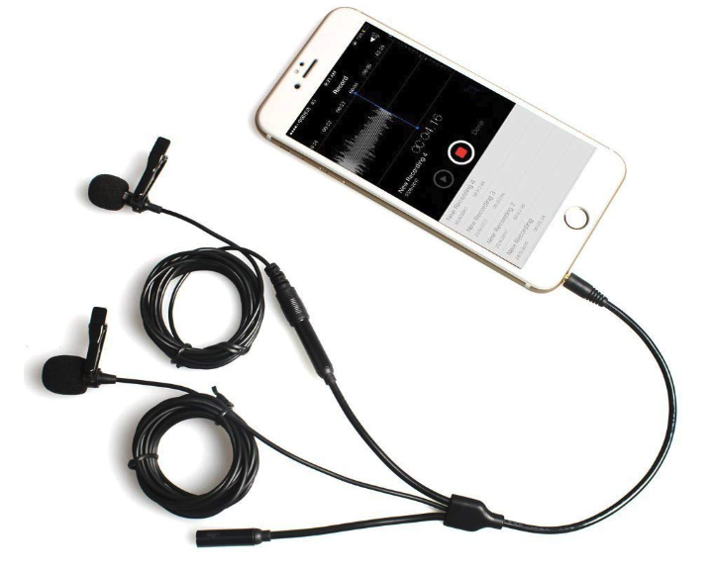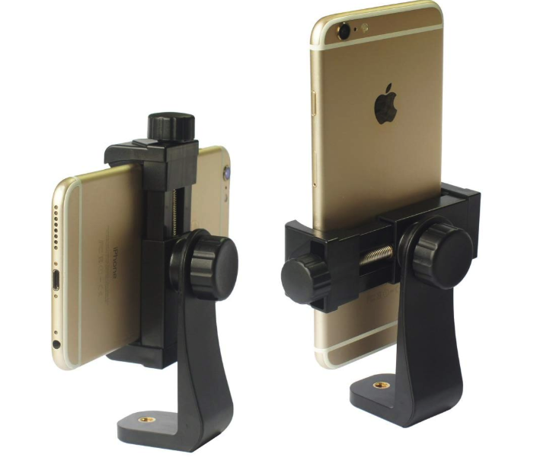
Recommended Supplies
USB external hard drive / flash drive
Specs: Minimum 64GB flash drive, must be USB 3.0 for fastest file transfer speeds. Recommended to invest in a larger external hard drive to backup all files for this course and others.
Click here for a link to a recommended flash drive (64GB).
Click here for a link to a recommended flash drive (128GB).
Click here for a link to a recommended external hard drive (2TB).

Required Digital Access
Lynda.com
Follow the instructions here to access Lynda.com with your ONYEN. http://software.sites.unc.edu/lynda/

Adobe Premiere
Follow the instructions here to create an Adobe ID and install the required software for free: http://software.sites.unc.edu/software/adobe-creative-cloud/

YouTube or Vimeo account
You must use or create an account to publish your videos for this course. A YouTube account is included with any Gmail account, and there is no storage limit on YouTube accounts. A Vimeo account is free to create, but free accounts have restrictions on the total GB you can upload each week. Publishing your work on YouTube is easy and free, but Vimeo can have a more professional reputation.

Accreditation
The Hussman School of Journalism and Media accrediting body outlines a number of values you should be aware of and competencies you should be able to demonstrate by the time you graduate from our program. Learn more about them here: http://www2.ku.edu/~acejmc/PROGRAM/PRINCIPLES.SHTML - vals&comps
No single course could possibly give you all of these values and competencies, but collectively, our classes are designed to build your abilities in each of these areas. In this class, we will address a number of the values and competencies, with special emphasis on the “Professional values and competencies” listed below.
- Understand concepts and apply theories in the use and presentation of images and information.
- Demonstrate an understanding of professional ethical principles and work ethically in pursuit of truth, accuracy, fairness and diversity.
- Think critically, creatively and independently.
- Apply tools and technologies appropriate for the communications professions in which they work.

Course Goals
In particular, we focus on the last competency listed, regarding the application of tools and technologies.
- You will become familiar with the functions and limits of the equipment and software introduced in class.
- You will develop an understanding of how to evaluate technical quality and story flow.
- You will be able to plan and execute a short, clean, logically-flowing video product.
- You will be able to understand the tools needed to create a graphic story
- You will be able to use a variety of strategies and tools to create a standards-based website.

Class Attendance
With the online learning environment, all instruction will be provided asynchronously through online videos. There will be one synchronous class discussion each week during scheduled class time that will be conducted via Zoom. These synchronous class discussions will be a time to provide and receive peer feedback on assignments and answer any questions. Attendance during the weekly class discussions is expected and will count towards participation in the course. It is important to attend each scheduled class meeting to receive immediate feedback and to improve your skills. Students who choose to miss class sessions are responsible for seeking out any feedback. It is not the instructor’s responsibility to follow up with or meet with a student to catch them up.

Late Assignments
Accepting late assignments is unfair to the students who have sacrificed to turn their work in on time. An automatic 10 percent deduction will be applied to each assignment turned in after the time it is due, provided the assignment is turned in on the same day it is due. An additional 10% deduction will be applied for each subsequent 24 hours that pass after the due date/time (i.e., 10 percent is taken off for each day). Deadlines will be posted on each assignment and in Sakai.

Independent Online Research
To teach you the necessary software tools to create your stories, this course will combine in-class demonstrations with online tutorials and videos. As beginners, it is inevitable that questions and technical problems will arise as you work with these tools. It is also not possible to cover every detail of a tool through in-class demos or assigned videos. The assignments will require you to learn how to learn new things independently, outside of direct instruction. While your instructor is always available to answer your questions and clarify any topic, this course will challenge you to troubleshoot your technical problems and figure out answers to your questions through independent online research. Before asking your question a technical or software-related question like “how do I…” or “ … isn’t working”, it is expected that you will research your question online. Invest some time looking at manuals, forums and documentation sites to see if someone else has addressed your question or problem before. If you have conducted independent research online and still can’t find your answer, reach out to your instructor through email, in class, or during office hours. In addition to asking your question, share what you learned during your research, a description of your problem, and any relevant screenshots.

Grading
Work is graded according to the highest professional standards. Grades in percentages are:

- A = 93-100%,
- A- = 90-92%,
- B+ = 87-89%,
- B = 83-86%,
- B- = 80-82%,
- C+ = 77-79%,
- C = 73-76%,
- C- = 70-72%,
- D+ = 67-69%,
- D = 60-66%
- F = 59% or below
Below is a guideline for how grades are described within this course:
- A: nearly perfect in execution, quality of work is exceptional
- A-: work is impressive in quality, very few problems in any area
- B+: very good performance, did more than required, might struggle in one area only
- B: solid effort, met all requirements, solid application of skill
- B-: needs a bit more polish, pretty good handle on things overall
- C+: good in one area of work, but consistent problems with another area
- C: followed instructions, seems to understand basics but did the minimum to pass
- C-: has glimpses of potential in a limited range
- D: did not demonstrate an understanding of the basics but tried
- F: did not demonstrate effort or understanding of basics, incomplete

Grading Criteria

Participation (see description below) | 5%
Video course work (includes exercises, quizzes, and video project) | 60%
Web/Design course work (includes exercises, quizzes and portfolio project) | 20%
Final project (includes final web page design and story/package integration) | 15%
Participation is your contribution within the scope of each class period, including arriving to online class sessions on time, asking questions, offering insights during class discussions, sharing feedback with peers, and general engagement with the daily material through online forums. The quality of your participation will be assigned a letter grade based on the guidelines above at the end of the course. You may check in with your instructor at any time during the course for individual feedback about the quality of your participation.
Exercises and quizzes are assigned to familiarize you with skills needed to complete the projects and are graded on completion and execution quality. Engagement with the exercises and quizzes will prepare you to achieve better work on your projects.
The video & web projects are assigned for you to demonstrate a mastery of the skills and storytelling techniques learned in class and with the exercises.
The final project is an integrated package delivered via text, design and video and housed on your portfolio website. The package must contain integrated elements (story text, video and any additional elements you may choose).

Honor Code
It is expected that each student in this class will conduct him/herself within the guidelines of the Honor System (http://honor.unc.edu). All academic work should be done with the high level of honesty and integrity that this University demands. If you have any questions about your responsibility or your instructor’s responsibility as a faculty member under the Honor Code, please feel able to see the course instructor, speak with the senior associate dean of undergraduate studies in this school, and/or speak with a representative of the Student Attorney Office or the Office of the Dean of Students.

Seeking Help
If you need individual assistance, it is your responsibility to meet with the instructor. If you are serious about wanting to improve your performance in the course, the time to seek help is as soon as you are aware of the problem, whether the problem is difficulty with course material, a disability, or an illness. Please feel able to contact the course instructor as soon as you perceive any warning signs of things that might adversely affect your class performance or final grade.

Diversity
The University’s policy on Prohibiting Harassment and Discrimination is outlined in the 2011-2012 Undergraduate Bulletin at http://www.unc.edu/ugradbulletin/. UNC is committed to providing an inclusive and welcoming environment for all members of our community and does not discriminate in offering access to its educational programs and activities on the basis of age, gender, race, color, national origin, religion, creed, disability, veteran’s status, sexual orientation, gender identity, or gender expression.
In this course, you are encouraged to represent diverse populations, diverse viewpoints, and diversity of perspective in your own work. You are also asked to be sensitive to the various backgrounds, perspectives, origins, and situations represented by the students in the course, the students, faculty, and staff at this university, and the residents of this state.

Special Needs
The University of North Carolina – Chapel Hill facilitates the implementation of reasonable accommodations, including resources and services, for students with disabilities, chronic medical conditions, a temporary disability or pregnancy complications resulting in difficulties with accessing learning opportunities.
All accommodations are coordinated through the Accessibility Resources and Service (ARS) Office. In the first instance please visit their website at http://accessibility.unc.edu, call the office at 919-962-8300, or email accessibility@unc.edu. A student is welcome to initiate the registration process at any time. However, the process can take time. ARS is particularly busy in the run-up to Finals and during Finals. Students submitting Self-ID forms at that time are unlikely to have accommodations set until the following semester.
Please contact ARS as early in the semester as possible.

Tentative Course Schedule: (subject to change)
The course schedule is meant as a guide to help you work through the course material in a timely manner while adhering to deadlines.
Class Meetings will occur on each Monday during class time 9:45 am to 11:15 am.
Color coding: Graded Assignment or Project Deadline, Pass/Fail Assignment Deadline, and Quiz Deadline
Sunday | Monday | Tuesday | Wednesday | Thursday | Friday | Saturday
Jun. 21 | 22  FIRST DAY OF CLASS  Class Meeting  Topic:  Intro. and Storytelling Basics | 23  Topic:  Visual Composition | 24  Deadline:  Final Story Plan  Topic:  Camera Operation  and Audio | 25  Deadline:  Audio/Video Practice  Topic:  Sequencing and B-roll Planning | 26  Deadline:  B-Roll Plan  Topic:  Editing Basics  Video Quiz #1 | 27
28 | 29  Class Meeting  Topic:  Editing Basics | 30  Deadline:  Action Sequence Assignment  Topic:  Interviewing | Jul. 1  Deadline:  Mini-Story Interview Plan  Topic:  Lighting | 2  Topic:  Storytelling | 3  INDEPENDENCE DAY HOLIDAY | 4
5 | 6  Class Meeting  Topic:  Advanced Editing | 7  Deadline:  Mini-Story Assignment  Topic:  Advanced Editing | 8  Deadline:  Video Project Interview  Topic:  Final Video | 9  Topic:  Final Video | 10  Topic:  Final Video  Video Quiz #2 | 11
12 | 13  Class Meeting  Topic:  Design | 14  Deadline:  Video Project  Topic:  HTML/CSS | 15  Topic:  HTML/CSS | 16  Deadline:  Infographic Assignment  Topic:  WordPress | 17  Topic:  WordPress | 18
19 | 20  Class Meeting  Topic:  Portfolio Project | 21  Deadline:  HTML/CSS Assignment  Topic:  Portfolio Project | 22  Topic:  Portfolio Project  Web Quiz | 23  LAST DAY OF CLASS  Deadline:  Portfolio Project  Topic:  Multimedia Story Project | 24 | 25

**Final Exam Period: Monday, July 27, 8am-11am. Final Multimedia Story Project deadline: Monday, July 27, 11:00 AM**
Day-by-day materials will be posted to the Sakai Resources page under the corresponding topic folders. All video lecture links, relevant readings, PowerPoints, and practice materials will be posted online.

