INTRODUCTION TO

DIGITAL STORYTELLING

UNC-Chapel Hill | School of Media and Journalism | MEJO 121 | Section 001

Welcome to this introductory media technology skills class at the UNC School of Media and Journalism. Our simple goals are to introduce you to some of the tools and skills needed to engage in multimedia storytelling in online environments. We aim to demystify the technical aspects of audiovisual information packaging by engaging in basic hands-on video and web exercises.
However, what distinguishes this class from a skills-only course is its focus on storytelling. We ultimately intend to provide familiarity with the tools and an understanding of how to develop a narrative story with all these tools. These are the skill sets needed for various professions in media and journalism.

Classroom and meeting time

Carroll Hall, Room 132
5:00-6:15pm
Instructor

Justin Kavlie
jkavlie@live.unc.edu
Office: Carroll Hall, Room 366
Office Hours: Wednesdays and Thursdays, 1pm-3pm; also by appointment
Required Supplies
There are no textbooks for this course. However, video recording software, a domain name and server space are among the required purchases. These supplies include:
FiLMiCPro app: We require the purchase of the FiLMic the app. FiLMiC Pro that provides the features of professional video cameras for iPhone and Android. The cost of this app is $14.99.
More information here: https://www.filmicpro.com/
Domain name & hosting space.
You will need to purchase these products for the Web portion of this class for approximately $20-$30 for your first year. More details will be provided in class. If you already have these products, you may reuse them for this class. Please inform instructor if this is the case.
Headphones
Must have a standard mini jack (⅛’’). Any wired (non-Bluetooth / not wireless) headphones you might use with your phone will work.
Smartphone
For your video assignments, you will record with your smartphone. Students who do not own a smartphone will be able to check out an iPod from the Hussman equipment room to record.

Wired lavalier microphone with headphone monitoring
Lavalier or stick microphones will be needed for the best audio quality. You will need to purchase a lavalier microphone with headphone monitoring (pictured below). Here is the link to an option on Amazon:
Lavalier microphone. The cost for this one is $24.99
NOTE: in some cases, to use these devices with an iPhone, an adapter is required. You may purchase the Lightning to 3.5mm Headphone Adapter from the UNC Bookstore or on Amazon.
Smartphone mount
Tripods will be available for checkout from the Hussman equipment room. However, you will need to purchase a mount for your phone. You may find an example here (pictured below).
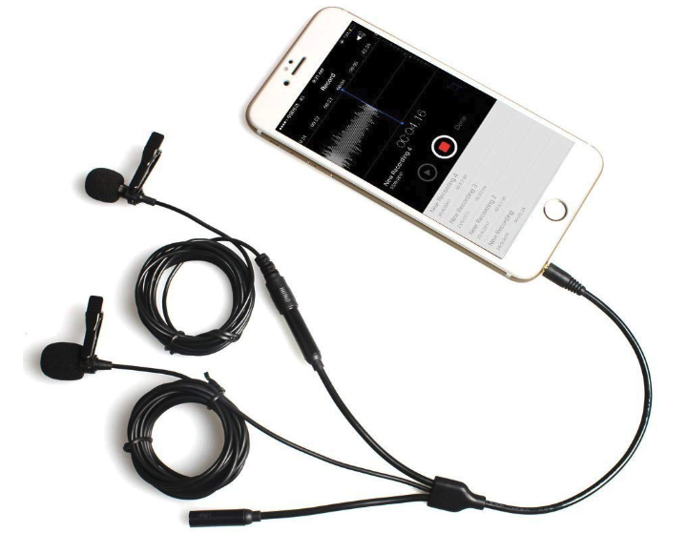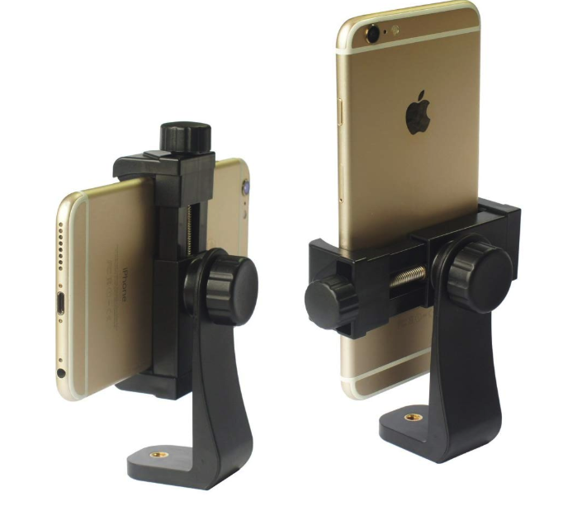
Recommended Supplies
USB external hard drive / flash drive
Specs: Minimum 64GB flash drive, must be USB 3.0 for fastest file transfer speeds. Recommended to invest in a larger external hard drive to backup all files for this course and others.
Click here for a link to a recommended flash drive (64GB).
Click here for a link to a recommended flash drive (128GB).
Click here for a link to a recommended external hard drive (2TB).
Tripod
Tripods may be checked out of the Hussman equipment room, but you can use your own if you like. A smartphone mount will be required if you choose to use the tripods from the equipment room (see above).
Required Digital Access
Lynda.com
Follow the instructions here to access Lynda.com with your ONYEN. http://software.sites.unc.edu/lynda/

Adobe Premiere
Follow the instructions here to create an Adobe ID and install the required software for free: http://software.sites.unc.edu/software/adobe-creative-cloud/

YouTube or Vimeo account
You must use or create an account to publish your videos for this course. A YouTube account is included with any Gmail account, and there is no storage limit on YouTube accounts. A Vimeo account is free to create, but free accounts have restrictions on the total GB you can upload each week. Publishing your work on YouTube is easy and free, but Vimeo can have a more professional reputation.
Computer Labs
You can download some of the required software to your own laptops for the projects required in this course. You may find that Adobe Premiere runs slowly on your laptop, depending on its hardware. As a student in this course, you have access to the MJ-School’s computer labs, which have all necessary required software tools installed. Find details about accessing those computer labs here: http://jomclabaccess.web.unc.edu/

Equipment Room

As a student in this course, you can check out equipment related to this course from the Hussman equipment room, located in the Park Library. It is your responsibility to keep track of all appointments and equipment room rules, and to treat your borrowed equipment professionally and respectfully. Failure to do so may result in revoked equipment room privileges.

Course Goals
The School of Media and Journalism accrediting body outlines a number of values you should be aware of and competencies you should be able to demonstrate by the time you graduate from our program. Learn more about them here: http://www2.ku.edu/~acejmc/PROGRAM/PRINCIPLES.SHTML - vals&comps
No single course could possibly give you all of these values and competencies, but collectively, our classes are designed to build your abilities in each of these areas. In this class, we place our emphasis on the last six bullet dots under "Professional values and competencies" in the link above.
In particular, we focus on the last competency listed, regarding the application of tools and technologies.
- You will become familiar with the functions and limits of the equipment and software introduced in class.
- You will develop an understanding of how to evaluate technical quality and story flow.
- You will be able to plan and execute a short, clean, logically-flowing video product.
- You will be able to understand the tools needed to create a graphic story
- You will be able to use a variety of strategies and tools to create a standards-based website.

Attendance Policy
Similar to having personal time off (PTO) at work, you are allotted TWO absence without need to justify or explain your reasons for the missed class. Similar to extending beyond one's allotted PTO, any additional absence past the two allotted days will result in a half-grade deduction (e.g., a B becomes a B- after two absences) for each additional day of absence. As this course is project-based and cumulative in its delivery of technical information, it is important to attend each scheduled course day to receive new information and to practice new skills. Students who choose to miss class are responsible for understanding the topics taught that day. It is not the instructor’s responsibility to follow up with or meet with a student to catch them up.
Late Assignments
Accepting late assignments is unfair to the students who have sacrificed to turn their work in on time. An automatic 10 percent deduction will be applied to each assignment turned in after the time it is due, provided the assignment is turned in on the same day it is due. An additional 10% deduction will be applied for each subsequent 24 hours that pass after the due date/time (i.e., 10 percent is taken off for each day). Deadlines will be posted on each assignment and in Sakai.

Independent Online Research
To teach you the necessary software tools to create your stories, this course will combine in-class demonstrations with online tutorials and videos. As beginners, it is inevitable that questions and technical problems will arise as you work with these tools. It is also not possible to cover every detail of a tool through in-class demos or assigned videos. The assignments will require you to learn how to learn new things independently, outside of direct instruction. While your instructor is always available to answer your questions and clarify any topic, this course will challenge you to troubleshoot your technical problems and figure out answers to your questions through independent online research. Before asking your question a technical or software-related question like “how do I…” or “ … isn’t working”, it is expected that you will research your question online. Invest some time looking at manuals, forums and documentation sites to see if someone else has addressed your question or problem before. If you have conducted independent research online and still can’t find your answer, reach out to your instructor through email, in class, or during office hours. In addition to asking your question, share what you learned during your research, a description of your problem, and any relevant screenshots.
Grading
Work is graded according to the highest professional standards. Grades in percentages are:

- A = 93-100%,
- A- = 90-92%,
- B+ = 87-89%,
- B = 83-86%,
- B- = 80-82%,
- C+ = 77-79%,
- C = 73-76%,
- C- = 70-72%,
- D+ = 67-69%,
- D = 60-66%
- F = 59% or below
Below is a guideline for how grades are described within this course:
- A: nearly perfect in execution, quality of work is exceptional
- A-: work is impressive in quality, very few problems in any area
- B+: very good performance, did more than required, might struggle in one area only
- B: solid effort, met all requirements, solid application of skill
- B-: needs a bit more polish, pretty good handle on things overall
- C+: good in one area of work, but consistent problems with another area
- C: followed instructions, seems to understand basics but did the minimum to pass
- C-: has glimpses of potential in a limited range
- D: did not demonstrate an understanding of the basics but tried
- F: did not demonstrate effort or understanding of basics, incomplete

Grading Criteria

In-class participation (see description below) | 5%
Video course work (includes exercises, quizzes, and video project) | 60%
Web/Design course work (includes exercises, quizzes and portfolio project) | 20%
Final project (includes final web page design and story/package integration) | 15%
In-class participation is your contribution within the scope of each class period, including arriving to class on time, asking questions, offering insights during class discussions, sharing feedback with peers, and general engagement with the daily material. The quality of your participation will be assigned a letter grade based on the guidelines above at the end of the course. You may check in with your instructor at any time during the course for individual feedback about the quality of your participation.
Exercises and quizzes are assigned to familiarize you with skills needed to complete the projects and are graded on completion and execution quality. Engagement with the exercises and quizzes will prepare you to achieve better work on your projects.
The video & web projects are assigned for you to demonstrate a mastery of the skills and storytelling techniques learned in class and with the exercises.
The final project is an integrated package delivered via text, design and video and housed on your portfolio website. The package must contain integrated elements (story text, video and any additional elements you may choose).

Honor Code
It is expected that each student in this class will conduct him/herself within the guidelines of the Honor System (http://honor.unc.edu). All academic work should be done with the high level of honesty and integrity that this University demands. If you have any questions about your responsibility or your instructor’s responsibility as a faculty member under the Honor Code, please feel able to see the course instructor, speak with the senior associate dean of undergraduate studies in this school, and/or speak with a representative of the Student Attorney Office or the Office of the Dean of Students.

Seeking Help
If you need individual assistance, it is your responsibility to meet with the instructor. If you are serious about wanting to improve your performance in the course, the time to seek help is as soon as you are aware of the problem, whether the problem is difficulty with course material, a disability, or an illness. Please feel able to contact the course instructor as soon as you perceive any warning signs of things that might adversely affect your class performance or final grade.
Diversity
The University’s policy on Prohibiting Harassment and Discrimination is outlined in the 2011-2012 Undergraduate Bulletin at http://www.unc.edu/ugradbulletin/. UNC is committed to providing an inclusive and welcoming environment for all members of our community and does not discriminate in offering access to its educational programs and activities on the basis of age, gender, race, color, national origin, religion, creed, disability, veteran’s status, sexual orientation, gender identity, or gender expression.
In this course, you are encouraged to represent diverse populations, diverse viewpoints, and diversity of perspective in your own work. You are also asked to be sensitive to the various backgrounds, perspectives, origins, and situations represented by the students in the course, the students, faculty, and staff at this university, and the residents of this state.
Special Needs
The University of North Carolina – Chapel Hill facilitates the implementation of reasonable accommodations, including resources and services, for students with disabilities, chronic medical conditions, a temporary disability or pregnancy complications resulting in difficulties with accessing learning opportunities.
All accommodations are coordinated through the Accessibility Resources and Service (ARS) Office. In the first instance please visit their website at http://accessibility.unc.edu, call the office at 919-962-8300, or email accessibility@unc.edu. A student is welcome to initiate the registration process at any time. However, the process can take time. ARS is particularly busy in the run-up to Finals and during Finals. Students submitting Self-ID forms at that time are unlikely to have accommodations set until the following semester.
Please contact ARS as early in the semester as possible.
Tentative Course Schedule: (subject to change)
(Homework/Readings listed on each day is DUE the following class period)
Week | Date | Topic
1 | 1/8 | General overview of class and policies:  - Review syllabus  - Equipment policy and assets for class  Homework:  - Create Adobe ID: Watch: Getting an Adobe ID  - Watch Logging in to Adobe  - Work on Final Story Idea sheet on Sakai (Word doc found in Sakai)  - Student Survey link on Sakai  - Read: Picking the right media for a story  - Filmmaking 101: Camera Shot Types  - Composition and Graphics—Composition–Setting the Scene (http://www.cybercollege.com/tvp022.htm)  - Composition and Graphics—Elements of Composition I (http://www.cybercollege.com/tvp023.htm)  Equipment Room:  - https://equipmentroom.mj.unc.edu/
2 | 1/13 | Visual Composition 1:  - Review policies, equipment room, questions.  - Discussion  - Rule of thirds  - Nose and head room  - Framing  Homework:  - Work on final story idea submission (Word doc found in Sakai)  - Create Vimeo and/or YouTube account (needed to embed video on website and submit final videos)  - Consume Media, notice shot composition, how is a story told in commercials  - Composition and Graphics—Elements of Composition II (http://www.cybercollege.com/tvp024.htm)  - Composition and Graphics—Elements of Composition III (http://www.cybercollege.com/tvp025.htm)
 | 1/15 | Visual Composition 2:  - Review composition day 1  - Discussion  - Angles  - Shot types  - Aesthetic information  Homework:  - Work on final story idea submission  - READ: Intro to FilMic Pro. Watch video Tutorials  DUE Saturday 1/18 @ Midnight:  - Complete final story ideas submission (Word doc)
3 | 1/20 | NO CLASS – Dr. Martin Luther King, Jr. Day
 | 1/22 | Camera Operation:  - Review composition day 2  - Intro to Filmic Pro Orientation  - Setting Up  - Recording and Reviewing Footage  - Focus, White balance, Exposure, Zoom  - In class practice with settings  - Assign Video Exercise 1  Homework:  - Work on final video story
4 | 1/27 | In-Class Practice Day  - Review camera operation  Homework:  - TBD
 | 1/29 | Audio:  - Microphones and Audio  - Recording Natural Sound vs Ambient Sound  - In class practice with audio  - Assign Video Exercise 2 and 3  Homework:  - Continue working through Premiere Pro Tutorials  - Read this article and watch video: Using Music to Tell Your Story  - Pick a partner and action sequence  DUE Saturday 2/1 @ Midnight:  - Video Exercise 1 – Video/Audio Homework Due
5 | 2/3 | Sequencing:  - Review Composition  - Sequencing (and what is b-roll?)  - Thinking about continuity  - Avoiding jump cuts  - 180-degree rule  - Cutaways and insert shot  - In class practice sequence  Homework:  - Continue watching Premiere Pro Tutorials  - Begin planning your b-roll shoot
 | 2/5 | B-Roll Planning:  - Review Sequencing  - Shooting a sequence from a plan  - Gathering wide, medium and tight, variety  - Importance of planning to tell a “story”  - Shooting to Edit  Homework:  - Watch Shooting effective b-roll: Lynda.com  - Watch How to Shoot Better B-Roll: Quick Filmmaking Tips  DUE Saturday 2/8 @ Midnight:  - Video Exercise 2 – B-Roll Planning Homework Due
6 | 2/10 | Editing 1:  - Intro to Premiere Pro  - Basic Premiere Functions  Homework:  - Video Editing—Continuity Editing (http://www.cybercollege.com/tvp050.htm)  - Video Editing—Continuity Editing 2 (http://www.cybercollege.com/tvp051.htm)  - Video Editing—Solving Continuity Problems (http://www.cybercollege.com/tvp052.htm)  - Video Editing—Technical Continuity (http://www.cybercollege.com/tvp053.htm)  - Begin to think of your interview: when, where, who?  - Work on sequence edit  - Continue working through your Adobe Premiere Tutorials found in Sakai
 | 2/12 | Editing 2:  - Continue Editing Process  - Assign Video Exercise 4 and 5  Homework:  - Continue working through your Adobe Premiere Tutorials found on Sakai  - Watch Basic Interview Lighting Techniques - SMAPP Series video.  - Pick a partner and a topic for the Interview and Mini-story assignments  DUE Saturday 2/15 @ Midnight:  - Video Exercise 3 – Sequence Edit Homework Due
7 | 2/17 | Lighting:  - Three-point lighting  - Types of light  - Using light  - Interview lighting  Homework:  - Continue watching Adobe Premiere Tutorials
 | 2/19 | Interviewing:  - Interview lighting  - Interview set up  - Interview technique  - Questions  Homework:  - Capture the interview for your mini-story  DUE Saturday 2/22 @ Midnight:  - Video Exercise 4 – Interview Capture Homework Due
8 | 2/24 | Storytelling:  - Shot variety  - Where to make your edits  Homework:  - TBD
 | 2/26 | Cleaning Footage:  - Techniques to add polish to your piece  - Final Questions for your Interview: What focus are you after?  - What are your B-roll Ideas? Permissions?  Homework:  - Shoot your interview for final video story  - Finish Mini-Story  DUE Saturday 2/29 @ Midnight:  - Video Exercise 5 – Mini-Story Homework Due
9 | 3/2 | Lab Day:  - Working on your interview  Homework:  - Interview due for final video story due Saturday, March 6
 | 3/4 | Lab Day:  - Working on Final Video story  Homework:  - Plan your b-roll shot list and locations  Soft Deadline Friday 3/6 @ Midnight:  - Final Video Interview Due
10 | 3/9-3/13 | NO CLASS – Spring Break
11 | 3/16 | Lab Time:  - Work on building your final story.  Homework:  - TBD
 | 3/18 | Design Basics 1:  - Basics of good design  - Composition of your website  - Choosing colors  Homework:  - Create a layout of your site. What graphics do you want or need to create?  DUE Saturday 3/21 @ Midnight:  - Final Edited Video Story Due via YouTube/Vimeo link
12 | 3/23 | Design Basics 2:  - Fonts  - DIY design programs  Homework:  - Download Atom software to your computer to use in class on 3/25
 | 3/25 | HTML:  - Learning HTML  - In-class practice  - Assign HTML/CSS Web Exercise  Homework:  - Finish in class HTML practice assignment. Where to submit TBD
13 | 3/30 | HTML/CSS:  - Continuing with HTML  - Learning CSS  - In-class practice  Homework:  - Finish in class CSS practice assignment. Where to submit TBD
 | 4/1 | CSS:  - Follow-up Q&A  - Lab time for web page exercise  - Beginning WordPress  Homework:  - Watch Tutorial Video on purchasing website and installing WordPress  DUE Saturday 4/4 @ Midnight:  - HTML/CSS Web Exercise Homework Due
14 | 4/6 | WordPress:  - Creating website and installing on Go Daddy  - WordPress pt 1 Planning your pages  Homework:  - TBD
 | 4/8 | WordPress Continued:  - WordPress pt 2  Homework:  - TBD
15 | 4/13 | WordPress Continued:  - Finish WordPress  - What is your content  Homework:  - TBD
 | 4/15 | Lab Day:  - Putting it all together  - In-class time for questions and/or work on final project
16 | 4/20 | Lab Day:  - In-class time for questions and/or work on final project
 | 4/22 | Lab Day:  - In-class time for questions and/or work on final project  DUE Saturday 2/25 @ Midnight:  - Final Website Due  - Final Multimedia Webpage Due
FINAL EXAM
- Presentation of final project

Monday, April 27 @ 4 pm

DUE by Final Exam Time:
- Re-edited Final Video if desired.

