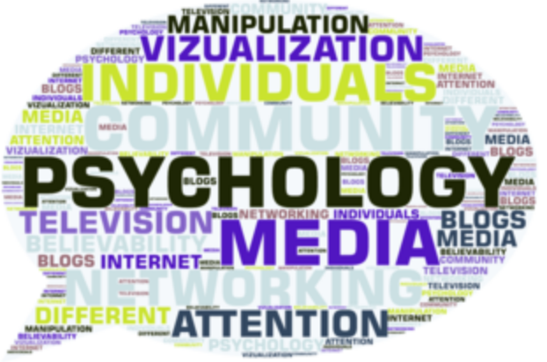
MEJO 710
Psychology of Audiences
Fall 2020

Instructor information:
Rhonda Gibson, Ph.D. (please call me Rhonda)
Carroll Hall Room 376
gibsonr@email.unc.edu (Email is the best way to reach me for non-time-sensitive questions.)
Cell Phone: (919) 699-6567 (Text or call if your questions are time sensitive.)
Office Hours: Tuesday & Thursday 10 a.m. – 12:15 p.m. and by appointment
(Do not hesitate to ask for an evening appointment if you need one.)

Course overview and goals:
An understanding of audiences is important for professional communicators, regardless of what industry they work in or what jobs they hold. This class will introduce you to the field of media psychology, which seeks to understand the connections among digital media use, message content, and effects on users. We will examine the role that audience beliefs, attitudes, emotions, personalities, motivations, and racial and cultural backgrounds play in information processing, decision making, and social interactions. Throughout the semester, we will also specifically focus on the psychology of oppression and the cultural-psychological roots and effects of racism.

We will consider the differences between online and offline worlds, the influence of digital social networks, and the evolution of audience research methodologies. We will apply this knowledge to situations in consumer behavior; news selection and consumption; political decision-making; and health behavior. The end goal of this course is to more fully understand audience behavior and experience when using digital media so that you, as professional communicators, can better use digital media for socially constructive personal and professional purposes.

Course objectives:
- Understand how the notion of an “active audience” has been constructed over time and how digital media have altered assumptions
- Understand the complex differences between online and in-person communication and the relationship of each to individual behavior
- Understand how key aspects of media psychology (i.e., emotions, motivations, cultural identity) influence ways that audiences select, perceive, consume, and are affected by mediated messages
- Examine the cultural-psychological causes and effects of oppression and racism and the role played by media/communication
- Learn how to apply media psychology-related insights to specific situations involving consumer, news consumption, political, and health behaviors
- Understand the strengths and limitations of key primary research methodologies used to examine audience media use and the effects of media on audience attitudes and behavior
- Demonstrate the ability to apply what you have learned to a multi-component project
- Lead and participate in thoughtful and respectful class discussions that examine the assigned material as well as other topics related to media psychology, communication, and diverse viewpoints
- Develop specific strategies for creating and deploying socially constructive digital media content and/or technologies

Required readings: (note that most of the books are available through UNC Libraries and do not need to be purchased)

Cialdini, R. B. (2007). Influence: The psychology of persuasion. New York: HarperCollins. (You will need to purchase or otherwise access this book.)
Cialdini, R. B. (2016). Pre-suasion: A revolutionary way to influence and persuade. New York: Simon & Schuster. (You will need to purchase or otherwise access this book if you want to read the full version. A shorter summary is available at no charge through the library.)
David, E. J. R., & Derthick, A. O. (2018). The psychology of oppression. New York: Springer Publishing Co. (Available online at no charge through UNC Libraries)
Dill, K. E. (Ed.). (2013). The Oxford handbook of media psychology. Oxford, UK: Oxford Handbooks Online. (Available online at no charge through UNC Libraries)
Eyal, N. (2014). Hooked: How to build habit-forming products. New York: Portfolio/Penguin Books. (You will need to purchase or otherwise access this book.)
Giles, D. C. (2003). Media psychology. Mahwah, NJ: Lawrence Erlbaum. (Available online at no charge through UNC Libraries)
Meyer, E. (2014). The culture map: Breaking through the invisible boundaries of global business. New York: Public Affairs. (Available online at no charge through UNC Libraries)
Napoli, P. (2011). Audience evolution: New technologies and the transformation of media audiences. New York: Columbia University Press. (Available online at no charge through UNC Libraries)
Yarrow, K. (2014). Decoding the new consumer mind: How and why we shop and buy. New York: John Wiley & Sons. (Available online at no charge through UNC Libraries)

Note: These readings will be supplemented by academic and industry research reports, case studies, and videos as appropriate.

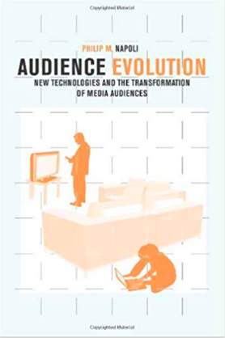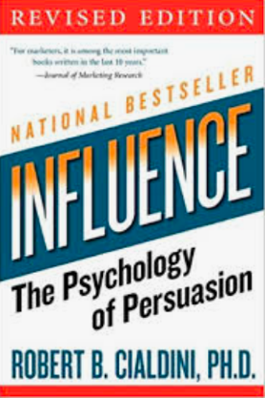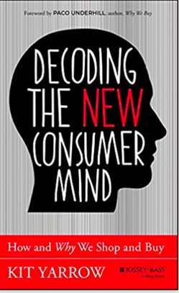

Graded assignments:
(NOTE: You can find additional information about each of these assignments under the
Assignments heading in the class Sakai site.)

•Class project topic memo (due Sunday, Aug. 30 by 8 p.m. EST and worth 5% of the course grade)

Your topic for the class project must focus on some practical professional communication/media goal and be grounded in some aspect of media/audience psychology. Your topic memo should explain and describe the topic you will use for the class project and its relevance to your professional goals. The memo should also provide sufficient context to show that the topic is worthy of consideration and substantial enough to support significant research.

•Abbreviated annotated bibliography and revised topic description (due Sunday, Sept. 20 by 8 p.m. EST and worth 15% of the course grade)
Class library site to help with this assignment: https://guides.lib.unc.edu/c.php?g=1054800&p=7661606

This assignment will prepare you to write your academic paper and create your industry-focused deliverable. For this assignment you will provide a detailed annotation for 5-7 key academic and trade sources that are relevant to your selected topic. For each entry in your bibliography, you should explain the study’s methodology and findings, a critique of its quality, and its specific relevance to your topic. For articles that are not reports of research studies, you should summarize the content of the article, critique its quality, and explain its relevance to your topic. Items in your bibliography should address the history/context of your topic, the concepts/variables involved in the topic, as well as the findings of research relevant to the topic. Please use APA style for this assignment.

At least half of your bibliography entries should be about scholarly journal articles related to your topic of research. You may also include trade and industry publications, but these cannot substitute for academic research. Please note that your annotations should NOT simply be copied from the abstract of the articles. Also, your paragraph summaries need to be in your own words and light on direct quotations. It is essential that you thoroughly read the articles that you are using to develop a complete understanding of how they fit in with your topic. In addition to your article summaries, your bibliography should include an opening section that explains the issue that you are focusing on and its relevance to communication professionals.

•Academic paper (due Sunday, Oct. 25 and worth 25% of the course grade)
8-10 page academic paper in APA style. This is a review of existing research from academia and industry. The introduction to the paper paragraph should fully describe your project topic, explain which areas of research within fields of media psychology and audience studies are most relevant to your topic, and conclude with a “roadmap” statement for the paper. The rest of the paper should review academic and industry research findings relevant to your topic. What research has been done and by whom? What are the findings? Are the findings uniform in their application to your topic? If not, what are the reasons for the conflicting results?
•Industry-focused deliverable (Due Sunday, Nov. 15 at 8 p.m. EST and worth 25% of the course grade)
This item should demonstrate what you have learned about your topic based on your review of existing literature. Prepare it as though your boss has asked you to tackle a topic at work, and you are telling or showing them what you have learned. This can take a variety of forms, but it cannot be similar to your academic paper. You could produce a multi-media slide deck using one of the many presentation software options available. You could create a video explaining best practices for addressing the topic. You could produce a series of advertisements or social media posts that illustrate knowledge about persuasion that you have learned. You could produce a podcast explaining the relevance of your information for a lay audience or specialized audience.
•Class presentation (due the final week of class and worth 10% of the course grade)
During the final week of class, each of you will post your industry-focused deliverable to the Sakai Discussion Board, along with a 4-5 sentence explanation of why you chose that topic and the key insights you gained. You’ll also be responsible for answering questions classmates may have about your materials. Post your materials to the Discussion Board no later than 8 p.m. EST on Tuesday, Nov. 17. All discussion closes at noon on Sunday, Nov. 22.

•Discussion Board (due weekly and worth 20% of the course grade)
The final 20 percent of the course grade is devoted to the quality of your participation in the weekly discussion forums. As you well know, the success of any graduate seminar depends on the quality of discussion that we engage in, so please speak up! For most weeks of class, there will be two general threads of discussion: one related to understanding the key concepts and findings of the assigned readings/videos and one related to applying those materials to specific professional communication settings.

It is expected that all of you will participate in both of these threads each week with at least one substantive original post for each thread and at least one response post (responding to one of your classmates’ posts) for each thread. Your top 12 weekly discussion grades will be used to compute this component of your course grade. (Please note that you are expected to post at least something to the Discussion Board each week, even if that week will not be one of your top 12. If you must be completely absent from the Discussion Board for an entire week because of some major extenuating circumstance, please notify me in advance.)

The schedule for the Discussion Board is as follows: Monday and Tuesday are reading/thinking days. Please do both. Discussion Board opens at 6 a.m. EST on Wednesday and closes at midnight EST on Sunday. You are required to post on at least two of the five days that the Discussion Board is open. (Please do not take this to mean that it’s acceptable to post at 11:55 p.m. on Thursday and 12:05 a.m. on Friday and count that as two separate days!) It is expected that you will check in with the Discussion Board and read your classmates’ posts even on (most) days that you do not post yourself. Early and/or late posts are not counted for grading purposes.

A weekly discussion grade of P can be earned by completing the required four original and response posts, demonstrating an understanding of the assigned material and an ability to apply it to a practical professional setting.

A weekly discussion grade of H can be earned by increasing the quality (more so than the quantity) of your posts. H grades are reserved for those who bring high-quality additional information to the discussion, making connections that are not already made by the assigned readings, the instructor or classmates. These posts help others synthesize and apply the material and/or suggest new ways of examining the issue under consideration.

A weekly discussion grade of L can be earned by completing fewer than the required number of posts and/or by doing overly brief or superficial posts that fail to show an understanding and application of the assigned material.

A weekly discussion grade of F can be earned by not posting to the Discussion Board in a given week.

General Policies:

Policy on academic integrity: Students are expected to conform to the Honor Code in all academic matters. For more information on the Honor Code, please visit the following URL: https://studentconduct.unc.edu/honor-system/honor-system-procedures or feel free to speak to me or someone at the Office of the Student Attorney General or the Office of the Dean of Students.

Accreditation Competencies: The School of Journalism and Media’s accrediting body outlines a number of values you should be aware of and competencies you should be able to demonstrate by the time you graduate from our program. Learn more about them here: http://journalism.ku.edu/acejmc-professional-values-competencies
No single course could possibly give you all of these values and competencies; but collectively, our classes are designed to build your abilities in each of these areas. In this class, we will address a number of the values and competencies, with special emphasis on these specific items from "Professional values and competencies" in the link above:
•understand concepts and apply theories in the use and presentation of images and information;
•demonstrate an understanding of professional ethical principles and work ethically in pursuit of truth, accuracy, fairness and diversity;
•think critically, creatively and independently;
•conduct research and evaluate information by methods appropriate to the communications professions in which they work

UNC policies for online courses
1. By enrolling as a student in this course, you agree to abide by the University of North Carolina at Chapel Hill policies related to the Acceptable Use of online resources. Please consult the Acceptable Use Policy (http://help.unc.edu/1672) on topics such as copyright, net-etiquette and privacy protection.
2. As part of this course you may be asked to participate in online discussions or other online activities that may include personal information about you or other students in the course. Please be respectful of the rights and protection of other participants under the UNC Chapel Hill Information Security Policies (https://its.unc.edu/about-us/how-we-operate-2/) when participating in online classes.
3. When using online resources offered by organizations not affiliated with UNC Chapel Hill, such as Google or YouTube, please note that the Terms and Conditions of these companies and not the University's Terms and Conditions apply. These third parties may offer different degrees of privacy protection and access rights to online content. You should be well aware of this when posting content to sites not managed by UNC Chapel Hill.
4. When links to sites outside of the unc.edu domain are inserted in class discussions, please be mindful that clicking on sites not affiliated with UNC-Chapel Hill may pose a risk for your computer due to the possible presence of malware on such sites.

Weekly topics:

Week 1, Aug. 10-16: Historical construction of "the audience" & introduction to media psychology
Week 2, Aug. 17-23: The psychology of oppression, racism, and stereotyping
Week 3, Aug. 24-30: Components of persuasion, part I
Week 4, Aug. 31-Sept. 6: Components of persuasion, part II
Week 5, Sept. 7-13: Audience-focused research methodologies; IRB
Week 6, Sept. 14-20: Emotions in media selection and processing, decision making, and behavior
Week 7, Sept. 21-27: The role of identity and personality in media selection and processing, decision making, and behavior
Week 8, Sept. 28-Oct. 4: The role of habits in media selection and processing, decision making, and behavior
Week 9, Oct. 5-11: The role of social networks/social influence in media selection and processing, decision making, and behavior
Week 10, Oct. 12-18: Class paper/project work week
Week 11, Oct. 19-25: The role of cultural differences in media selection and processing, decision making, and behavior
Week 12, Oct. 26-Nov. 1: Application of media psychology: Consumer behavior
Week 13, Nov. 2-8: Application of media psychology: News consumption behavior
Week 14, Nov. 9-15: Application of media psychology: Political and health behavior
Week 15, Nov. 16-22: Project deliverable presentations

